Energy Savings

Acknowledgement
We would like to express our sincere thanks to our colleagues from all the Supreme Audit Institutions that participated in writing this document.

Writing this study was a collaborative effort of the following project team members from the Supreme Audit Office of the Czech Republic – Mr Benjamín Groll, Mr Martin Kolman, Ms Eva Moravcová, Ms Sylva Müllerová, Mr Petr Neuvirt, Mr Michal Rampír, Ms Helena Vorbová, and Ms Barbora Zochová.

As well as the Supreme Audit Office of the Czech Republic, the following institutions actively contributed to this project: the Supreme Audit Institutions of China, Egypt, Ethiopia, Estonia, Morocco, the Netherlands, Norway, Philippines, Slovakia, Swaziland, the United States, the United Kingdom, and Zambia.

We would also like to thank all the Supreme Audit Institutions that sent us information about audits carried out in the field of energy savings and energy efficiency and/or responded to our questionnaire survey as well.

The secretariat of the INTOSAI Working Group on Environmental Auditing and the Steering Committee members provided valuable help at various stages of the project.

We wish our readers much success in applying this study to their audits.

Mr Miloslav Kala Dr. H. Harry Azhar Azis, M.A.
President the Supreme Audit Chairman of the Board of Badan
Office of the Czech Republic Pemeriksa Keuangan

Table of contents

Acknowledgement 2
Abbreviations and acronyms 4
Glossary 6
Foreword 8
Executive summary 9
Introduction 12
Chapter 1 - Background information on the issue of energy savings 13
1.1 Definition of the term “energy savings” 15
1.2 Definition of the term “energy efficiency” 16
1.3 Overview of measures and tools to promote energy savings and energy efficiency 16
1.4 Importance of energy savings and energy efficiency 18
1.5 Energy savings and energy efficiency by sector 21
1.5.1 Buildings 21
1.5.2 Transport 24
1.5.3 Industry 26
1.5.4 Appliances and equipment 28
Chapter 2 - Political and legal framework in the area of energy savings and energy efficiency in selected regions 31
2.1 Energy policies 31
2.2 Financing energy efficiency and energy savings measures 34
2.3 Regional energy efficiency and energy savings initiatives 35
2.3.1 Energy efficiency in the European Union 35
2.3.2 Energy efficiency in the USA 37
2.3.3 Energy efficiency in China 41
2.3.4 Energy efficiency in Africa 45
2.4 Indicators for measuring energy efficiency 47
Chapter 3 - Auditing energy savings issues (INTOSAI community experience) 51
Sources 67

Abbreviations and acronyms
CAFE Corporate Average Fleet Efficiency Standards
CFL Compact Fluorescent Lamp
CIS Commonwealth of Independent States
CRC Carbon Reduction Commitment
DCCEE Department of Climate Change and Energy Efficiency
DEWHA Department of the Environment, Water, Heritage and the Arts
DRET Department of Resources, Energy and Tourism
E3 Equipment Energy Efficiency Program
EECA Energy Efficiency and Conservation Authority
EED Energy Efficiency Directive
EEIG Energy Efficiency Information Grants (programme)
EEMR Energy Efficiency Market Report
EISA Energy Independence and Security Act
EPA Environmental Protection Agency of the United States
EPAct Energy Policy Act
EPC Energy Performance Contracting
ESCO Energy Service Company
EU European Union
FYP Five-Year Plan
GAO Government Accountability Office
GDP Gross Domestic Product
GIB Green Investment Bank
GIZ Deutsche Gesellschaft für Internationale Zusammenarbeit
HDV heavy-duty vehicle
ICT information and communication technologies
IEA International Energy Agency
INTOSAI International Organisation of Supreme Audit Institutions
INTOSAI WGEA INTOSAI Working Group on Environmental Auditing
LDV light-duty vehicle
MEPs minimum energy performance requirements
MEPS minimum energy performance standards
Mtce Million tonnes of coal equivalent
Mtoe Million tonnes of oil equivalent
N/A not applicable
NABERS National Australian Built Environment Rating System
NAECA National Appliance Energy Conservation Act
NFEPWM National Fund for Environmental Protection and Water Management
NHTSA National Highway Traffic Safety Administration
ODEX Odyssee energy efficiency index
OECD Organisation for Economic Co-operation and Development
PFE Programme for Improving Energy Efficiency in Energy Intensive Industries
RES renewable energy resources
SAI Supreme Audit Institution
SME small and medium enterprises
TFC total final (energy) consumption
TPES total primary energy supply
TWh terawatt hour
US DOE Department of Energy of the United States
VFE vehicle fuel economy
WEO World Energy Outlook
WEC World Energy Council

Glossary
Energy services – include a wide range of activities, such as energy analysis and audits, energy management, project design and implementation, maintenance and operation, etc.
Passive house concept - refers to a building, for which thermal comfort can be achieved solely by post-heating or post-cooling of the fresh air mass, which is required to achieve sufficient indoor air quality conditions – without the need for additional recirculation of air.
EPC - Energy Performance Contracting is a form of ‘creative financing’ for capital improvement which allows funding energy upgrades from cost reductions. Under an EPC arrangement an external organisation (ESCO) implements a project to deliver energy efficiency, or a renewable energy project, and uses the stream of income from the cost savings, or the renewable energy produced, to repay the costs of the project, including the costs of the investment. Essentially the ESCO will not receive its payment unless the project delivers energy savings as expected.
Energy intensity - a ratio of energy consumption to another metric, typically national gross domestic product in the case of a country's energy intensity. Sector-specific intensities may refer to energy consumption per household, per unit of commercial floor space, per dollar value industrial shipment, or another metric indicative of a sector. Improvements in energy intensity include energy efficiency and conservation as well as structural factors not related to technology or behaviour.
Energy efficiency market - refers to markets delivering goods and services that reduce the energy required to fuel our economies.
Intelligent illumination (Smart lightning) - refers to stage lighting that has automated or mechanical abilities beyond those of traditional, stationary illumination.
LEED - LEED, or Leadership in Energy & Environmental Design, is a green building certification programme that recognizes best-in-class building strategies and practices. To receive LEED certification, building projects satisfy prerequisites and earn points to achieve different levels of certification. Prerequisites and credits differ for each rating system, and teams choose the best fit for their project.
Euro 2 emissions standards - European emission standards define the acceptable limits for exhaust emissions of new vehicles sold in EU member states. The emission standards are defined in a series of European Union directives staging the progressive introduction of increasingly stringent standards (EURO 2 – Directives 94/12/EC and 96/69/EC).
ODEX - is the index used in the ODYSSEE-MURE project to measure the energy efficiency progress by main sector (industry, transport, households) and for the whole economy (all final consumers). For each sector, the index is calculated as a weighted average of sub-sectoral indices of energy efficiency progress; sub-sectors being industrial or service sector branches or end-uses for households or transport modes. A value of ODEX equal to 90 means a 10% energy efficiency gain.
Building envelope (Building shell) – is the physical separator between the conditioned and unconditioned environment of a building including the resistance to air, water, heat, light, and noise transfer.

Foreword
The fundamental objectives of the INTOSAI Working Group on Environmental Auditing (the INTOSAI WGEA) are to help Supreme Audit Institutions (SAIs) understand specific matters linked to environmental audit, to promote exchange of experience and information among audit institutions, and to publish audit manuals, handbooks, and other informative materials for use in environmental auditing.
At the 11th meeting of the INTOSAI WGEA, which took place in Tanzania in June 2007, the Supreme Audit Office of the Czech Republic took on the role of the leader of a project called Sustainable Energy. The outcome of the Sustainable Energy project was Auditing Sustainable Energy – Guidance for Supreme Audit Institutions, a handbook used as an aid for audit in the field of renewable energy resources.
With a view to capitalizing upon its previous experience with this project, the Supreme Audit Office of the Czech Republic proposed leading a new project called Energy Savings at the 15th INTOSAI WGEA meeting in Tallinn in 2013. Unlike the Auditing Sustainable Energy handbook, the output of this project is a study focusing on the issue of energy savings and scrutiny of this issue in audit work by audit institutions.

Executive summary
The study’s principal aims are to highlight the importance of energy savings as a potential area to be audited by SAIs and to elaborate this topic by focusing on examples, case studies, and SAIs’ best practice in this field.
In cooperation with the INTOSAI WGEA secretariat, a survey with three questions focusing on Energy Savings project has been sent to SAIs (77 members of INTOSAI WGEA). We have asked the following questions:
- What tools are used by your state to support or increase energy savings or energy efficiency?
- Do you have set indicators for measuring energy savings and energy efficiency? If so, what are they?
- Did your SAI perform an audit of these indicators during the last five years?
58 INTOSAI WGEA members have completed and sent back the survey, which represents 77% of all respondents. The survey results show that 48 of questioned countries use tools for energy savings and 32 INTOSAI WGEA members state that there are set or defined indicators for energy savings in their country. Also, it follows from the project survey that only a small number of SAIs (14 members of the INTOSAI WGEA) have focused their audits on energy efficiency or energy savings topic in the last five years.
We have divided our study in the following three chapters:

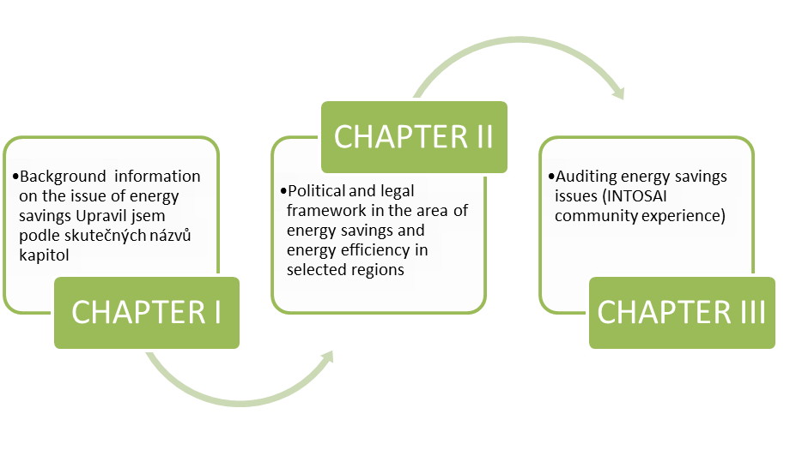
We understand energy savings as a quantity of energy saved by the adoption of certain measures; we determine the saved energy by measuring or estimating consumption before and after one or more measures have been implemented.
From auditors’ point of view, however, it is necessary to understand the potential areas of energy efficiency from the generation phase through the energy supplies phase right up to the phase of energy consumption. The role of audit institutions and auditors themselves is to evaluate the impacts of policies or measures implemented by governments seeking to promote energy savings or energy efficiency in individual phases of this chain.
According to materials of the World Bank published in 2014, mechanisms for financing energy efficiency investments include credit lines, demand-side management by utilities, utility-funded consumer financing, energy efficiency funds, risk-sharing programs, energy saving performance contracting, equity funds, and others. All of these mechanisms work best within a context of clear national objectives for energy efficiency and supporting policies that create a market pull for investments in energy efficiency.
Governments can use various tools, direct and/or indirect, to manage the state energy policy focusing on measures to improve energy efficiency and energy savings. Energy efficiency measures can be then applied in various phases of the energy chain:
- energy savings in energy generation;
- energy savings in energy supplies;
- energy savings in consumption.
Measures aiming to promote energy savings and energy efficiency can be further divided into measures concerning buildings, transport, industry, and appliances and equipment.
The fundamental source of audit criteria is national legislation which encompasses legislation on environmental protection, support for renewables, the budget, and management of state finances, accounting, taxes, public procurement, etc. There is no international treaty laying down binding rules on energy savings.
In addition to legislation, governments adopt energy policies/programmes by setting priorities and targets for the energy sector. Auditors may compare the actual state of affairs with the commitments laid down in such policies/programmes and/or may examine the economy, efficiency, and effectiveness of these policies/programmes.
Important parts are the parts regarding energy efficiency and energy savings in the European Union, China, the USA, and also in Africa. According to reports from public available sources (e. g., the International Energy Agency), these regions should be the most important players in the close future. It also follows from the example about possible future primary energy demand (Scheme 1). The role of these regions will be very important in the next period.

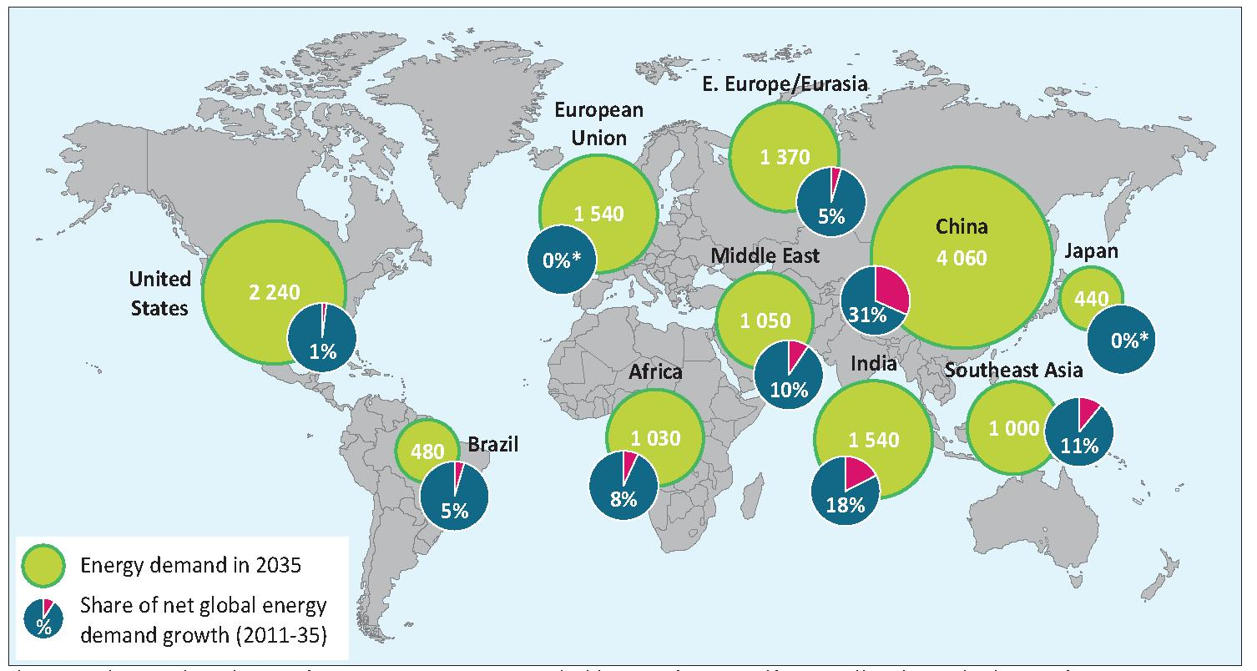
- Primary energy demand, 2035 (Mtoe)
Source: IEA, World Energy Outlook 2013
The case studies presented in Chapter 3 are based on audits conducted by SAIs from all around the world and their common topic/subtopic is energy savings or energy efficiency respectively.
Based on the case studies analysis, we have identified the following challenges for SAIs:
- lack of base data required for efficient planning of energy savings and energy efficiency;
- improvement in risk analyses (proper identification of potential risks);
- identification of barriers to investments created by current economic conditions;
- cost-effectiveness of programmes/projects - establishing and application of cost-effectiveness criteria adapted to projects’ circumstances;
- unclear results of and improvements in energy efficiency area; problems with quantification of savings – whether the set goals and energy savings were reached; whether the tools achieved its intended impacts;
- reports on effects of measures for energy efficiency in a coordinated and clear way;
- monitoring/prevention of fragmentation and overlapping of programmes to prevent duplication of funding;
- in audits, monitoring project performance and reporting on whether programme objectives are being achieved;
- control and management of risks with respect to large grants and new technologies; higher efficiency of control mechanisms.

Introduction
The International Energy Agency (IEA) regards energy efficiency as the most important source of energy. A considerable part of its World Energy Outlook 2013 (WEO 2013) was devoted to this subject. This is the evidence that the heightened attention has been paid to energy efficiency recently.
This is not a source of energy in the true sense of the word but a question of saving the energy resources humankind can draw on. A number of countries are just starting to reach the conclusion that the cheapest and safest energy is energy that does not have to be generated. This is a major turning point in the way we think about energy.
Energy efficiency is featuring strongly in political documents, because governments are trying to reduce excessive energy consumption, improve energy security, and cut greenhouse gas emissions.
The main objective of drawing up this study was to elaborate further the theoretical parts of the Auditing Sustainable Energy handbook, specifically those parts devoted to energy consumption, energy savings, and energy efficiency, including states’ energy policy tools. This objective is consistent with the 1st goal of the INTOSAI WGEA Work Plan for 2014–2016 that is “Update existing and develop new guidance materials available to SAIs, conduct research studies on emerging topics in environmental auditing”.
The study’s principal aims are to highlight the importance of energy savings as a potential area to be audited by SAIs and to elaborate this topic focusing on examples and case studies and SAIs’ best practice in this field.
The term “energy savings” used in this handbook means result of the use of technologies and techniques that reduce the quantity of energy consumed. We therefore understand energy savings as a quantity of energy saved by the adoption of certain measures; we determine the saved energy by measuring or estimating consumption before and after such measures have been implemented.
Energy savings also have significant side effects such as mitigation of climate change, the improvement of the business environment, support of energy saving living, or generating energy from renewables.
The study is divided into the following three chapters:
- Background information on the issue of energy savings;
- Political and legal framework in the area of energy savings and energy efficiency in selected regions;
- Auditing energy savings issues (INTOSAI community experience).

Chapter 1 - Background information on the issue of energy savings
The Auditing Sustainable Energy handbook contained a diagram of the energy chain. Energy efficiency and energy savings were there understood only as a supplement of the energy consumption phase. Today, the energy chain must be interpreted in a new way. Energy efficiency plays a significant role not only in the energy consumption phase, but also in the energy generation and energy supply phase. The final energy savings then represent calculated results of measures implemented in these three phases.
- The energy chain
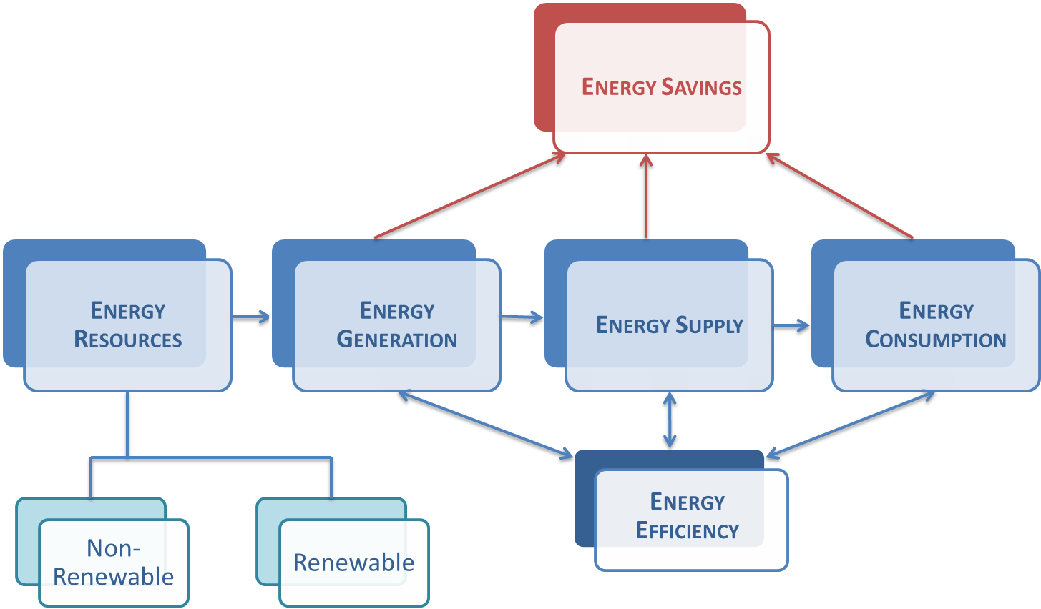
From auditors’ point of view, however, it is necessary to understand the potential areas of energy efficiency from the generation phase through the energy supplies phase right up to the phase of energy consumption. The role of audit institutions and auditors themselves is to evaluate the impacts of policies and/or measures implemented by governments seeking to promote energy savings or energy efficiency in the individual phases of this chain.
Governments can use various tools, direct and indirect, to manage the state energy policy focusing on measures to improve energy efficiency and energy savings.
Since 2008, the IEA has drawn up and regularly updated a report entitled 25 Energy Efficiency Policy Recommendations (recommendations). This is a publication intended to help IEA member countries achieve the benefits of energy efficiency across their economies. These recommendations affect the following priority areas:

Cross-sectoral | Lighting
1) Data collection and indicators | 14) Phase-out of inefficient lighting products
2) Strategies and action plans | 15) Energy-efficient lighting systems
3) Competitive energy markets, with appropriate regulation | Transport
4) Private investment in energy efficiency | 16) Mandatory vehicle fuel-efficiency standards
5) Monitoring, enforcement and evaluation | 17) Measures to improve vehicle fuel efficiency
Buildings | 18) Fuel-efficient non-engine components
6) Mandatory building codes and MEPS | 19) Eco-driving
7) Net-zero energy consumption in buildings | 20) Transport system efficiency
8) Improved energy efficiency in existing buildings | Industry
9) Building energy labels or certificates | 21) Energy management
10) Energy performance of building components and systems | 22) High-efficiency industrial equipment and systems
Appliances and equipment | 23) Energy efficiency services for SMEs
11) Mandatory MEPS and labels | 24) Complementary policies to support industrial energy efficiency
12) Test standards and measurement protocols | Energy utilities
13) Market transformation policies | 25) Utility end-use energy efficiency schemes
Source: IEA, 25 Energy Efficiency Policy Recommendations, 2011
The IEA states that it has been substantial policy implementation and innovation in its member countries since 2009. All member countries have made progress in implementing the recommendations in all sectors, particularly in the appliance, lighting, and transport sectors, although further policy implementation is still needed (Scheme 3). Nevertheless, IEA member countries still have significant unexploited energy savings opportunities that could be achieved with additional energy efficiency policy implementation.
The IEA is currently developing new policy recommendations for developing countries. These will be created to reflect the regional, developmental, climatic, and cultural contexts of such countries.
In addition, the IEA Policies and Measures Databases provide a comprehensive inventory of information on energy efficiency policy packages in force or planned globally. These Databases cover IEA member countries, Clean Energy Ministerial countries, and many more. Because these Databases are regularly updated by the governments of IEA member countries, it provides a valuable tool for tracking latest policy developments, supporting the work of policy makers and market analysts both inside and outside the IEA. It is free to access online at: www.iea.org/policiesandmeasures/.
- Progress in implementation of IEA 25 recommendations by IEA countries
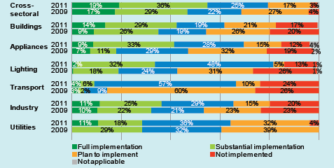
Source: IEA, Energy Efficiency Market Report 2013

1.1 Definition of the term “energy savings”
As mentioned in the introduction to this study, the term “energy savings” as used in this study means result of the use of technologies and techniques that reduce the quantity of energy consumed. We therefore understand energy savings as a quantity of energy saved by the adoption of certain measures; we determine the energy saved by measuring or estimating consumption before and after one or more measures have been implemented.
Within the EU energy savings are defined in Directive 2012/27/EU in its Article 2 (5) as follows:
Energy savings means an amount of saved energy determined by measuring and/or estimating consumption before and after implementation of an energy efficiency improvement measure, whilst ensuring normalization for external conditions that affect energy consumption.
The International Energy Agency defines energy savings as follows:
Energy savings is the estimated energy saved through a particular (energy efficiency improving) measure.
In the WEO 2013 report, the IEA divides energy savings into three items:
- reductions in the demand for modern energy services;
- savings due to fuel and technology switching;
- savings due to energy efficiency improvements.
All three definitions agree that energy savings are the result of certain actions and are measurable.

1.2 Definition of the term “energy efficiency”
Within the European Union, energy efficiency is defined by the said Directive No 2012/27/EU as follows:
Energy efficiency means the ratio of output of performance, service, goods or energy, to input of energy.
The International Energy Agency defines energy efficiency as follows:
Energy efficiency is a way of managing and restraining the growth in energy consumption. Something is more energy efficient if it delivers more services for the same energy input, or the same services for less energy input.

1.3 Overview of measures and tools to promote energy savings and energy efficiency
Every country, government, or state can use measures and tools to promote and improve energy savings or energy efficiency in the various phases of the energy chain:
- energy savings in energy generation;
- energy savings in energy supplies;
- energy savings in consumption.

The INTOSAI WGEA Auditing Sustainable Energy handbook mentioned several examples of measures to improve energy efficiency and energy savings in the following areas:
- Energy transformations – an overhaul of power plants and heat generating plants nearing the end of their service life. As a consequence this raises the electric energy generating efficiency, by:
- increasing combined production of heat and electric power (so-called co-generation);
- raising the electric power efficiency and central heat generation efficiency;
- cutting down the energy losses in transmission and distribution.

- End-consumers – here the focus of potential savings can be perceived primarily:
- In processing industries, e.g.
- adopting and implementing measures identified by energy audits;
- using modern, energy-saving technologies and procedures.
- In households, e.g.
- insulation of buildings, mitigation heat losses of buildings;
- supporting the passive house concept, low-energy, and zero-energy buildings;
- using energy-efficient appliances;
- suitable placing of electrical appliances;
- optimum temperature for economical heating;
- regulating indoor temperature;
- removing obstacles that hinder free circulation of heat;
- preventing heat leaks through windows and doors;
- energy-saving measures applied to the use of warm water;
- using LED or fluorescent lamps instead of incandescent light bulbs.
- In transportation, e.g.
- supporting public transport;
- modernizing the fleet of vehicles.

- Further potential instruments to achieve energy savings, such as:
- introducing an environmental tax reform;
- green bonuses;
- guarantees extended in respect of payback on investment (e.g. Energy Performance Contracting - EPC);
- monitoring and targeting;
- information and awareness-raising campaigns;
- educational activities focused on school establishments;
- technologically more exacting methods of production which at the same time are more friendly toward the environment.

1.4 Importance of energy savings and energy efficiency
Governments have implemented a wide range of policies and programmes such as energy efficiency standards, educational campaigns, obligations for market participants, and financial incentives to accelerate the development and adoption of energy efficiency measures. These policies and programmes have contributed to the improvement in energy efficiency recorded in OECD countries, along with on-going technological development, response to rising energy prices, and growing competition in industries forcing businesses to cut energy costs. The European Union is currently the region with the lowest energy intensity, while among the large consumer countries; the Commonwealth of Independent States (CIS) uses almost three times more energy per unit of GDP than Europe (World Energy Perspective 2013). In China, Africa, and the Middle East, the energy intensity is two times higher than the average in Europe. High energy intensities can be attributed to a number of factors, including the structure of the industry, the share of energy intensive sectors, low energy prices, and other. Latin America and OECD Asia & Pacific are about 15% above the European level, while India and other Asia are at the same level as the world average with energy intensity 50% higher than in Europe and slightly less than North America.
According to the IEA, the envisaged growth in energy demand up to 2035 will be caused primarily by increased demand in south Asia. China, only recently established as the world’s largest energy consumer, is projected to consume about 80% more energy than the USA (the next largest consumer; Scheme 4) in 2035. Looking at growth by fuel is just as unambiguous, with China having a larger increase than any country in demand for oil, gas, nuclear, hydro, wind, and solar. But the pace of energy demand growth does slow: growth in this decade will be slower than in the last, and in the 2020s growth will be less than half the level of the current decade.

- Primary energy demand, 2035 (Mtoe)
Source: IEA, World Energy Outlook 2013
The energy efficiency measures play an important role in mitigating the growth in demand for fossil fuels. Cumulative efforts to increase energy efficiency from 2012 reduce demand for coal, oil, and gas by almost one-fifth. While most oil savings arise from efficiency improvements in transport, industry and power generation are responsible for the bulk of efficiency savings related to coal and gas. Efficiency measures will most likely generate savings in oil demand in 2040 of 23 million barrels per day, or more than the current combined production of Saudi Arabia and Russia (Scheme 4). The gas savings in 2040, 940 billion cubic metres, are more than the current output of North America. The coal savings in 2040, 920 million tonnes of coal equivalent (Mtce), are equal to about one-third of China’s current coal production. This demonstrates the importance of energy savings and energy efficiency to all countries.
- Global fossil-fuel demand and cumulative energy efficiency savings by fuel in %

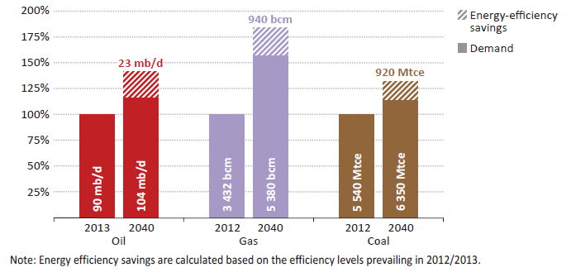
Source: IEA, World Energy Outlook 2014

The Energy Efficiency Market Report 2014 (EEMR 2014) estimates that investment in energy efficiency markets worldwide in 2012 were between USD 310-360 billion.
If there had been no efficiency gains since 2001, total final consumption in 2011 would have been 218 Mtoe higher. Energy efficiency has consistently reduced annual energy consumption over the past decade. The cumulative savings from efficiency improvements between 2001 and 2011 in these 18 countries was 1 731 Mtoe (Graph 2).

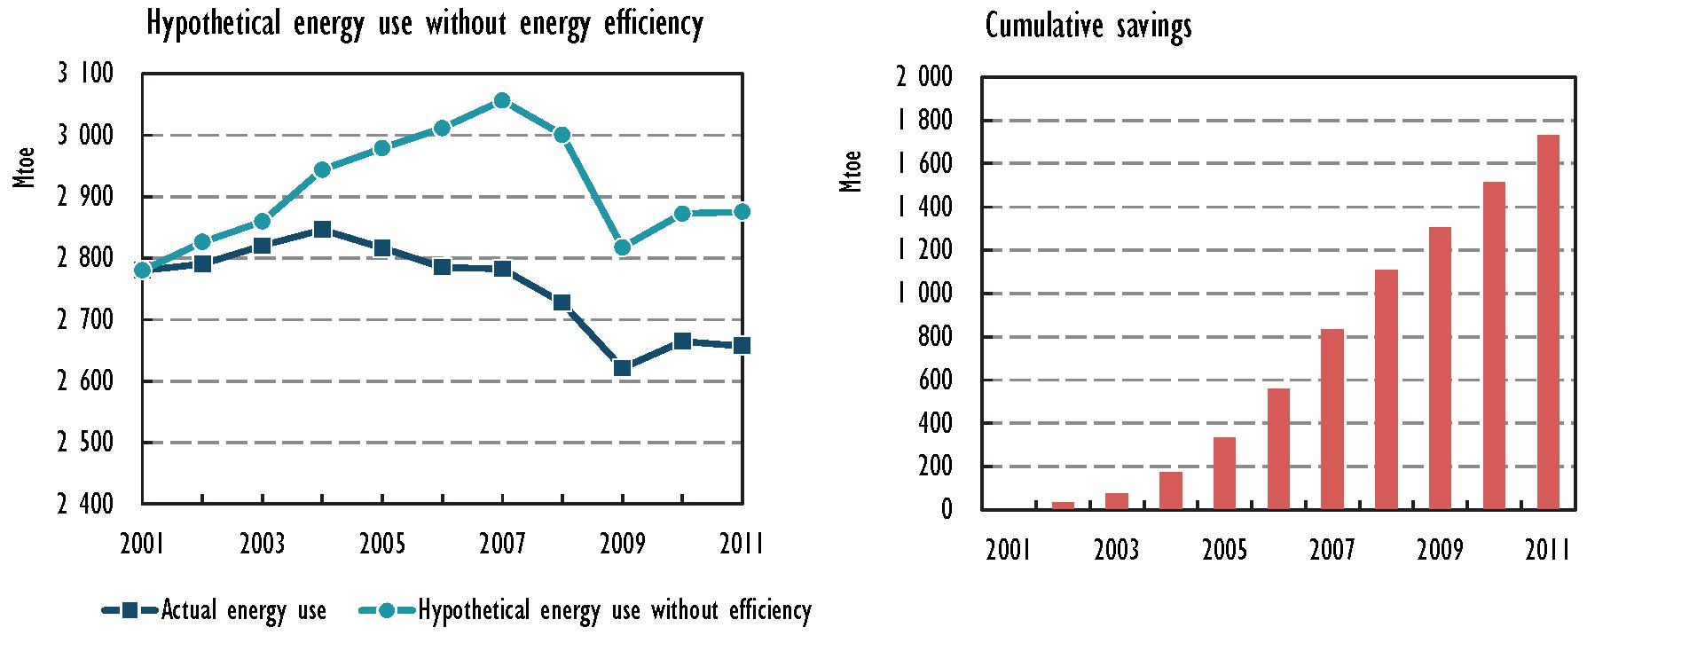
- Hypothetical energy consumption without energy efficiency and cumulative savings from energy efficiency improvements for a set of 18 IEA member countries, 2001 – 2011
Source: IEA, Energy Efficiency Market Report 2014

1.5 Energy savings and energy efficiency by sector

1.5.1 Buildings
The International Energy Agency says in its publication World Energy Outlook 2014 that the buildings sector accounts for one-third of today’s final energy consumption, with households accounting for about three-quarters and the services sector for about one-quarter.
Energy consumption in buildings will grow from approx. 3 000 Mtoe in 2012 to 3 900 Mtoe in 2040. This will be caused mainly by increasing living standards (economic growth, availability of electric power to inhabitants, etc.). Of all energy types, the biggest potential of growth lies in electric power (electric appliances supply, lighting, cooling). Coal and oil combustion represents a way of heating that is used less and less.
It the New Policies Scenario, the energy consumption in buildings is expected 7% lower (280 Mtoe) by 2040 in comparison to the current situation. More than half of this decrease will be caused by higher energy efficiency at the end consumer. The rest will be a result of lower demand for energy services, especially for heating, e. g., because of setting lower temperature at the thermostat. This has already happened in those countries where prices for end consumers were raised because of fossil-fuels subsidies had been abolished there (e. g., China, Russian Federation, and Near East). Another factor is switching to other forms of heating; it means using heat pumps above all.
In connection with better energy efficiency, the biggest savings are expected in heating rooms and water (43% of all savings) – as a result of better insulation of buildings, reconstruction and repairs, using more efficient boilers, or managing systems.
Another category is improvement of energy efficiency of appliances – e. g., refrigerators, washing machines, dishwashers, and air conditioning. Most of the above-mentioned savings flow from a policy for the adoption of or tightening up energy performance standards for appliances, such as the Eco-design Directive in the EU or Energy Star programme in the USA. However, the increasing rate of electric energy consumption is caused by smartphones, tablets, small electronics, and kitchen appliances that, in most cases, do not need to meet the standards or have energy labels. In 2013, such appliances used more than 600 TWh of electricity, i. e., 3% of the world´s demand. Implementation of more energy efficient technologies can reduce energy performance of appliances; the IEA calculated that it can be up to 65% lower.
At this moment, we can say that there exist three markets that will represent more than a half of all expected improvements in the field of energy efficiency: the USA, China, and the European Union.
This reflects the high level of their current energy consumption and their national policies whose aim is to make appliances more energy efficient and to improve/renovate building envelopes (including mandatory energy requirements in buildings codes in some US states, the Civil Construction Energy Conservation Design Standard in China, and the EU’s Energy Performance of Buildings Directive, and Eco-design and Energy Labelling Directive).

Energy efficiency policy in “buildings” (Energy Efficiency Policy Developments, IEA 2012)
Buildings hold great potential for cost‐effective energy savings. Governments can tap into these savings by:
→ requiring building energy codes and minimum energy performance requirements;
→ aiming for net‐zero energy consumption in buildings;
→ improving energy efficiency in existing buildings;
→ requiring building energy labels or certificates;
→ putting in place policies to improve energy performance of building components and systems.

Lighting
Lighting gained a lot of attention of end users in the past. Nowadays, it represents 18% (i. e., 150 Mtoe) of all electricity demand in buildings. It is expected that electricity consumption for lighting will be higher up to 260 Mtoe in the future due to growing demand. Without improving energy efficiency, this number would be 350 Mtoe.
- Electricity demand for lighting in buildings by contributing factor
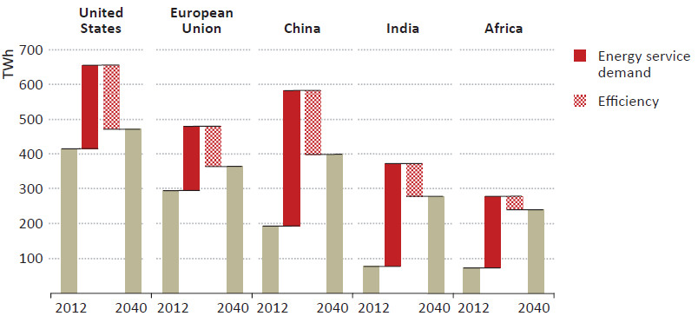
Source: IEA, World Energy Outlook 2014
There are mainly used incandescent light bulbs (51%), Compact Fluorescent Lamps (CFLs, 26%), and tube lights (17%) in the households today. In the service sector, strip lights represent two-thirds of all lighting sources and CFLs rate for 20%.
Switching from an incandescent light bulb to a CFL can reduce energy use by 75%, while switching to LEDs can reduce energy use by around 80% (World Energy Outlook 2014). In the commercial sector, switching from tube lights to intelligent illumination can reduce energy use by 25%.
With the view of rising energy requirements for lighting, many countries have implemented specific policy for efficiency such as withdrawal of incandescent bulbs or application of standards. With regard to these energy standards (e. g., in the USA and the EU), the demand for energy for lighting is rising much more slowly than in the past.

1.5.2 Transport
According to the EEMR 2014, investments in energy efficiency represent an important part of the overall energy efficiency market (e.g., for efficiency improvements in vehicles). This amount in absolute terms is valued at between USD 310-360 billion.
Energy use for transport represents 27% of world total final energy consumption (TFC) (2 445 Mtoe). Within all transport sectors, land-based transport is responsible for 76% of total energy use. Air and marine transport make up the remainder. Road vehicles, such as passenger light-duty vehicle (LDVs), two- and three-wheelers, buses, and freight trucks, make up 94% of land-based energy use. Of passenger road vehicles, passenger LDVs made up 95% of total energy use in OECD member countries (660 Mtoe) in 2010, with buses and two- and three-wheelers accounting for 4% and 1% respectively. In OECD non-member economies, passenger LDVs had a lower share of road vehicle energy use at 67% (281 Mtoe) in 2010. Buses used 21% (86 Mtoe) of road vehicle energy use, and two- and three-wheelers had a 12% share (50 Mtoe).
Efforts to improve the efficiency of transport systems can be effected through three distinct dynamics: “avoid, shift, and improve” (GIZ, 2004). This approach includes the application of technologies and practices that:
- enable people and goods to avoid motorised travel;
- shift travel to more efficient modes;
- lead to improved vehicle and fuel technologies.
According to the IEA, an estimated USD 80 billion is spent per year on investments in energy efficiency in passenger LDVs. Over the next ten years, passenger LDV purchases, particularly in OECD non-member economies, are expected to offer the largest market opportunity for energy efficiency deployment. Investment in efficient vehicles is expected to represent over 60% of all incremental investment in energy-efficient technologies globally during this period.
The most important short-term driver for energy efficiency investments in passenger vehicles is vehicle fuel economy (VFE) standards, which covered 70% of the global market in 2011, accounting for 50 million vehicles sold that year. Brazil, Canada, China, the European Union, India, Japan, Mexico, the Republic of Korea, and the USA have implemented or updated VFE standards for passenger LDVs that will increase average fuel economy to a range of 3.9 litres to 6.7 litres of gasoline equivalent per 100 kilometres. Standards provide a strong signal for markets to deploy efficient technologies and services over the next 20 years.
Energy efficiency improvements in the transport system could reduce fuel expenditure between USD 40 billion and USD 189 billion annually by 2020 depending on the adoption of new policies and scale of market implementation they achieve. Fuel expenditure is a key driver of transport efficiency investment, with global expenditure expected to reach USD 2.8 trillion in 2020.
Trucks and other heavy-duty vehicles (HDVs) account for a growing share of energy consumption in the freight sector, but policies to deploy more efficient HDVs have been less extensive than for passenger LDVs. Japan, the Republic of Korea, and the USA are implementing efficiency-based standards; standards focusing on greenhouse gases are being implemented in Canada. Energy efficiency market activity for HDVs is likely to intensify in response to new standards and the prospect of high oil prices.
While transport demand is increasing in OECD non-member economies, it is levelling off in OECD member countries, with a corresponding geographical shift in the potential energy efficiency market. Vehicle ownership is levelling off or even declining in OECD member countries, which still have the highest rates of vehicle use and distance travelled per vehicle. Passenger travel demand in OECD non-members is projected to continue to increase – by a further 90% between 2011 and 2020.
According to WEO 2014, in early 2014, India became the last major car market to adopt mandatory fuel-economy standards for passengers LDVs. The Indian Corporate Average Fuel Consumption standard specifies 4.8 l/100 km by 2021-2022. This corresponds to about a 15% increase in fuel efficiency compared with today’s average.
All major car markets – China, the European Union, North America, Japan, Brazil, India, and the Republic of Korea – have now established fuel-economy standards.
- Savings in energy demand and CO₂ emissions in transport from energy efficiency in the New Policies Scenario (Mtoe)
 | Demand |  |  | Change versus Current Policies Scenario
 |  |  |  | Total |  | Due to efficiency
 | 2012 | 2020 | 2040 | 2020 | 2040 | 2020 | 2040
Coal | 3 | 3 | 1 | 0 | 0 | 0 | 0
Oil | 2325 | 2563 | 2937 | -62 | -474 | -33 | -333
Gas | 91 | 116 | 229 | 10 | 62 | -1 | -10
Electricity | 26 | 34 | 82 | 1 | 20 | 0 | -2
Biofuels | 60 | 101 | 218 | 14 | 44 | -1 | -25
Total | 2504 | 2816 | 3467 | -37 | -347 | -35 | -369
CO₂ emissions (Gt) | 7.2 | 7.9 | 9.3 | -0.2 | -1.3 | -0.1 | -0.9
Source: IEA, World Energy Outlook 2014

The IEA in WEO 2014 estimated that the transport energy efficiency savings can be 370 Mtoe in total in 2040. About 70% of the savings are attributable to LDVs, with stricter fuel-economy standards in several regions.
Energy efficiency policy in transport (Energy Efficiency Policy Developments, IEA 2012)
The transport sector consumes approximately one‐fifth of global primary energy. This sector is highly dependent on oil and will account for nearly all future growth in oil use. Countries can implement the following policies and measures to address the growing demand for oil in the transport sector:
→ mandatory vehicle fuel efficiency standards;
→ vehicle fuel economy labels, vehicle taxes, infrastructure support and other measures to improve vehicle fuel efficiency;
→ international testing procedures for measuring tyre rolling resistance, mandatory fitting of tyre‐pressure monitoring systems MEPs for vehicle air conditioning;
→ eco-driving;
→ urban transport system efficiency planning.

1.5.3 Industry
As the IEA states, industry accounts for almost 40% of final energy consumption today. Industrial energy consumption grows annually by 1.3% between 2012 and 2040 in the New Policies Scenario, a rate of growth is lower than that seen over the past thirty years (1.7%). While energy intensive industries (steel, cement, chemicals, and paper) currently account for more than 60% of total energy consumption in industry, their share declines to 55% in 2040. This is a result of fast growth in non-energy-intensive industries and the relatively slower production growth in the steel and cement industries, particularly as production levels off in China as demand for buildings and infrastructure construction passes its peak.
In 2040, energy consumption in industry reaches 4 860 Mtoe in the New Policies Scenario, which is 320 Mtoe (6%) lower than in the Current Policies Scenario. Almost 60% of the savings can be attributed to improved energy efficiency, particularly in non-energy intensive industries. Most of the energy efficiency gains in energy-intensive industries realised in the New Policies Scenario are already incorporated in the Current Policies Scenario and most of the policies under consideration aim to reduce energy consumption in non-energy-intensive industries. These policies include incentives to adopt energy management systems and to undergo energy audits, the phase-out of fossil-fuel subsidies, the enhanced use of energy service companies and fiscal incentives. Energy efficiency improves fastest in motor-driven systems, steam systems, and furnaces for the provision of heat. The second most important driver for reducing energy consumption between the two scenarios is the reduction in the demand for energy services. Other drivers, including fuel switching and changes in industrial processes, play a lesser role.
- Savings in energy demand and CO2 emissions in industry from energy efficiency in the New Policies Scenario (Mtoe)
 | Demand |  |  | Change versus Current Policies Scenario
 |  |  |  | Total |  | Due to efficiency
 | 2012 | 2020 | 2040 | 2020 | 2040 | 2020 | 2040
Coal | 1047 | 1 171 | 1 133 | -31 | -92 | -12 | -37
Oil | 681 | 785 | 911 | -7 | -24 | -4 | -14
Gas | 641 | 771 | 1 103 | -14 | -69 | -9 | -44
Electricity | 689 | 872 | 1202 | -20 | -116 | -14 | -71
Heat | 131 | 143 | 153 | -2 | -3 | -2 | -7
Bioenergy* | 187 | 231 | 356 | -4 | -18 | -4 | -17
Total | 3 377 | 3 972 | 4 859 | -78 | -322 | -45 | -190
C0₂ emissions (Gt)** | 10.6 | 11.7 | 12.7 | -0.3 | -2.3 | -0.2 | -0.8
*Includes other renewables.
** CO₂ emissions include indirect emissions from electricity and heat.
Source: IEA, World Energy Outlook 2014
From a regional perspective, more than three-quarters of all energy efficiency savings in the industry sector are realised outside of the OECD (New Policies Scenario).
China makes the biggest contribution globally (31%), primarily because of the sheer scale of the remaining opportunities, coupled with the recently initiated and planned measures to phase out small, inefficient coal-fired boilers and to raise industrial energy performance standards.
The European Union has the second-highest savings, at 9%, driven by several elements of the Energy Efficiency Directive: mandatory and regular energy audits for large enterprises, encouragement for small and medium enterprises (SMEs) to undergo energy audits and incentives for the use of energy management systems.
Despite its significant potential to improve energy efficiency, Africa contributes only 5% of cumulative efficiency-related energy savings during the projection period because of the barriers (see also chapter 2.3.4) hindering the uptake of energy efficiency.
Cement production is the world’s third-largest energy-consuming industry (after chemicals and iron and steel). Worldwide cement production consumes more energy each year than Brazil. Given a projected peak in cement demand in China in the coming decade, global cement production in the New Policies Scenario increases by just 14% from 2012 to reach 4.3 billion tonnes in 2040. Global energy consumption in this industrial sector in 2040 is slightly lower than in 2012, as the energy consumption per tonne of cement declines, compared with today. In the New Policies Scenario, the energy intensity of cement production is reduced by 0.5% per year on average, a fairly modest rate that reflects the limited remaining energy savings potential.
The more than 700 waste heat recovery power systems adopted in China recently have led to substantial electricity savings, and strong potential remains in Asia and Latin America (IIP and IFC, 2014). The uptake of energy efficiency is limited in the Middle East and the USA partially because of their comparatively low energy prices, which make the adoption of more efficient equipment more difficult to justify and in some cases even uneconomic. In China and India, the energy intensity savings achieved in the New Policies Scenario are comparatively low because a significant share of current capacity has been added over the last decade, using, in most cases, the latest technology.
Energy efficiency policy in industry (Energy Efficiency Policy Developments, IEA 2012)
Industrial energy use accounts for roughly one third of global energy demand. While there is significant potential to decrease energy consumption in this sector, opportunities to improve energy efficiency are still underexploited. To tap savings and improve the competitiveness and productivity of companies, governments can:
→ Require energy management in industry;
→ Adopt MEPs for industrial equipment and systems;
→ Develop a package of specifically designed policies and measures to promote energy efficiency in SMEs;
→ Support improvements in industrial energy efficiency through complementary policies such as removing subsidies and encouraging investment in energy‐efficient industrial equipment.

1.5.4 Appliances and equipment
Appliances and consumer electronics are a growing source of energy consumption for households, fuelled by new appliances placed on the market to provide end uses such as recreation and communication. In most of the 18 countries evaluated, the demand for white goods (e.g., refrigerators and washing machines) is no longer growing significantly, while the efficiency of these appliances is increasing which reduces their total energy consumption. This stands in contrast to appliances such as televisions, personal computers, and other personal devices that are increasing in size or in other energy consumption requirements. For example, the energy intensity of televisions (in GJ per unit) rose by more than 50% in Australia, Canada, Denmark, France, and the Netherlands between 2001 and 2011.
- Change in energy intensity of large household appliances as a function of appliance stocks, 2001-11
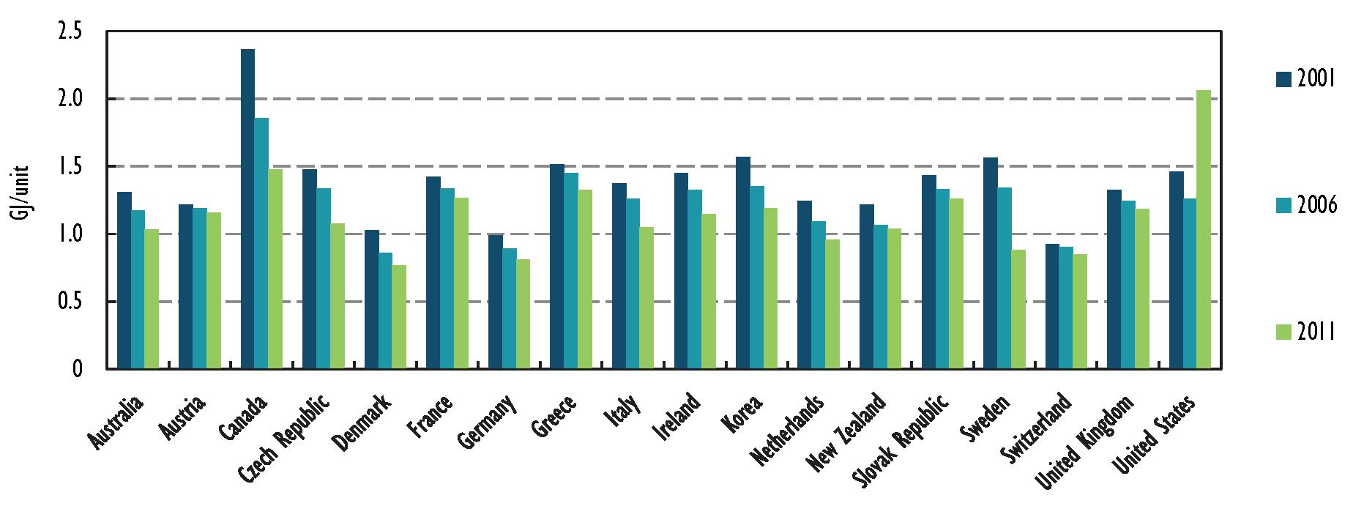
Notes: Large household appliances comprise refrigerators, freezers, dishwashers, washing machines, and clothes dryers. Data for Finland, Japan, and Spain are unavailable; data for the Slovak Republic do not include dishwashers, washing machines, or clothes dryers; data for the USA do not include dishwashers, washing machines, or clothes dryers until 2011, explaining why intensity increased.
Source: IEA, Energy Efficiency Market Report 2014
Energy efficiency policy
Appliances and equipment represent some of the fastest‐growing energy consumption. To achieve significant energy savings in this sector, governments can put in place:
- Mandatory minimum energy performance requirements (MEPs) and labels;
- Test standards and measurement protocols for appliances and equipment;
- Market transformation policies for appliances and equipment.
MEPs and labels
Governments are adopting and regularly updating the stringency of MEPs across a spectrum of appliances and equipment. For example, in the 2011‐2012 period, Australia, through the Equipment Energy Efficiency (E3) Program, has adopted four new or revised MEPS regulations for split‐system air‐conditioners, multi‐split system air‐conditioners, gas water heaters, and televisions. Since 1 October 2012, the Australian Greenhouse and Energy Minimum Standards Act came into effect. This legislation expands the E3 Program and replaces 7 state based laws, improving consistency and streamlining E3 processes to the benefit of the equipment suppliers. It also allows for a more comprehensive and stringent compliance programme to be introduced.
Canada’s regulations under the Energy Efficiency Act set minimum energy‐performance levels for 47 energy‐using products such as appliances, lighting, and heating and air‐conditioning. As of January 2013, products accounting for 80% of the energy used in homes and businesses are regulated. An additional set of new regulations will implement further new and revised standards for 16 products.
Malaysia is finalizing MEPS for televisions, air conditioners, fans, lightings, and refrigerators.
In Saudi Arabia, MEPs and labels exist for some air conditioners, refrigerators, and washing machines. Saudi Arabia is now expanding MEPs to larger air conditioners. MEPs are being developed for water and electric heaters.
Since August 2011, the US Department of Energy (US DOE) has updated minimum energy performance requirements for fluorescent lamp ballasts, washing machines, dishwashers, refrigerators, freezers and direct heating equipment, and agreements to update standards for distribution transformers, and to develop a voluntary standard for set‐top boxes were announced. The US DOE launched a new web‐based database of all product certification data in December 2011. In July 2011, the US DOE announced the most‐energy efficient products participating in the Energy Star labelling programme for the following categories: washing machines, refrigerators, televisions, central air‐conditioners, furnaces, and air and ground‐source heat pumps.

Chapter 2 - Political and legal framework in the area of energy savings and energy efficiency in selected regions

2.1 Energy policies
The Auditing Sustainable Energy handbook drew attention to the fact that there is no international treaty laying down binding rules on energy savings. Every country should choose its own strategy for implementing its energy policy. See Annex 2 of the Auditing Sustainable Energy for examples of criteria that can be used as sources of audit criteria.
The fundamental source of criteria is thus national legislation, which encompasses legislation on environmental protection, support for renewables, the budget, and management of state finances, accounting, taxes, public procurement, etc.
Government policies/programmes on energy savings or energy efficiency are another important source of criteria for audit work. Governments adopt energy policies/programmes setting priorities and targets for the energy sector. Auditors can then compare the actual state of affairs with the commitments laid down in such policies/programmes, or may examine the economy, efficiency and effectiveness of these policies/programmes or parts thereof.
Governments around the world are developing policy frameworks to increase the role of energy efficiency in meeting new energy demand. These new regulations often lead to the development of incentive programmes.
The typical policy framework in which incentive programmes are developed are either (1) direct government roll-outs with money raised through taxes or (2) mandatory savings goals (also referred as obligations) set for energy providers (also referred as utilities) to reduce their customers' energy use. This is illustrated in Scheme 5 (Based on the article published by Elsevier Ltd.).
Incentive programmes have been principally implemented by governments to fuel long-run growth of domestic clean product markets. By increasing production of efficient products that are at an early stage of development, incentive programmes help technology (and thus the market) mature and spur private-sector investment. Implementation of incentive programmes can also be motivated by the need to boost an economy in times of recession; governments deploy incentive programmes to stimulate economic activity while also promoting clean technology development.

- Incentive programme policy framework
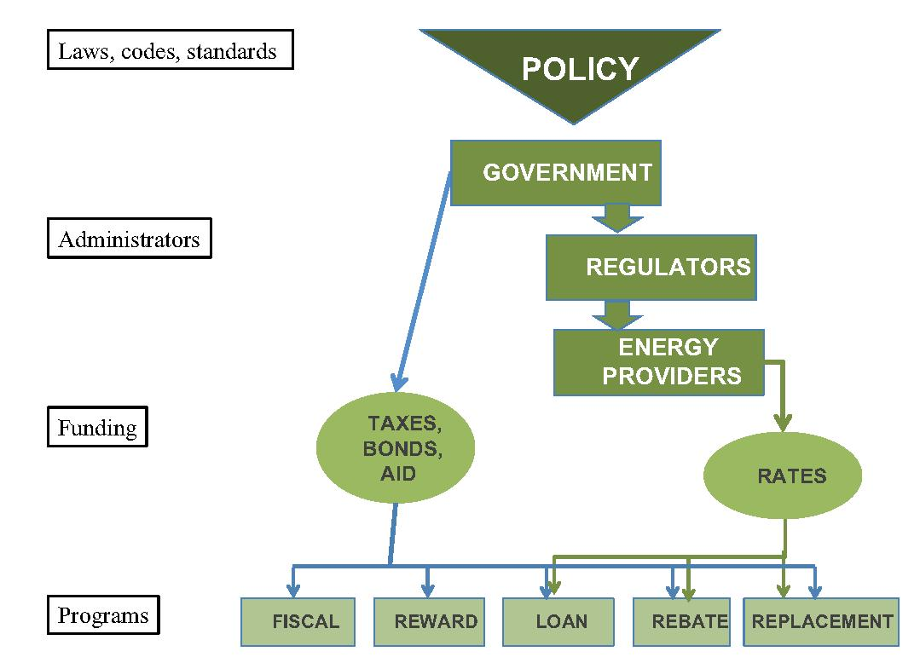

Source: International Energy Studies Group, Environmental Energy Technologies Division, Lawrence Berkeley National Laboratory, 2014.
New energy efficiency policies have been announced or introduced in many countries over the past year. China, the world’s largest energy consumer, is putting more emphasis on energy efficiency measures, in part to help cut air pollution, a major concern in many cities. New measures in industry include accelerating boiler renovation, phasing out small and inefficient coal-fired boilers and reducing outdated production practices in energy-intensive industries. In China’s transport sector, “yellow label” vehicles produced before the end of 2005 are to be phased out from 2015. At least half of all new buildings are to comply with the “green” building standard by 2015, which imposes design, construction, and operational requirements that reduce energy consumption.

- WEO 2014 presents an overview of selected energy efficiency policies for 2013 and 2014:
Region | Sector | New policy measure
China | General | Acceleration of the efficient use of coal in support of the goal to reduce coal use in several provinces, e.g. by phasing out small, inefficient coal-fired boilers.
 | Industry | Implementation of the phase-out of outdated production capacity in the steel, cement and glass industries, including closing or upgrading coal-fired boilers.
 | Buildings | More than 50% of new buildings to comply with "green" building standards from 2015. 400 million m² of buildings in Northern China are to be retrofitted.
 | Transport | Phase out (from 2015) low-efficient "yellow label" vehicles produced prior to 2005.
USA | General | Clean Power Plan proposed, which includes improving end-use energy efficiency as a central element of reducing C0₂ emissions from power plants.
 | Buildings | Announcement of stricter building codes and tighter standards for electric motors and commercial coolers and freezers, plus certain types of light bulbs.
 | Industry | Announcement of stricter standards for electric motors.
European Union | Buildings | Implementation of regulations for cooking appliances, space and water heaters, and power transformers within the framework of the Eco-design Directive. Revision of energy labelling for domestic ovens.
India | Transport | Introduction of vehicle fuel-economy standards requiring 5.5 1/100 km by 2016-2017 and 4.8 l/100km by 2021-2022, and subsidies for hybrid/electric cars.
 | Buildings | Energy Conservation Building Code mandatory nationwide by 2017 covering building envelope, lighting, heating, ventilation and air conditioning. New energy efficiency norms announced for 2015 for air conditioners and refrigerators.
Japan | Buildings and industry | Extension of the Top Runner Programme among others to commercial electric refrigerators and freezers, heat pump water heaters, self-ballasted light-emitting diodes (LED) lamps and three-phase induction motors. Announced targets for newly constructed buildings to be net-zero energy on average by 2030.
Middle East | Transport | Saudi Arabia: Announcement of a fuel-economy labelling for cars in 2015 and standards for imported vehicles up to 18.5 km/I (5.4 1/100 km).
 | Buildings | Saudi Arabia: Introduction of mandatory thermal insulation standards for new buildings and tightening of minimum energy performance standards (MEPs) for air conditioners. Public awareness campaign to cut electricity use. United Arab Emirates (Dubai): Introduction of compulsory building codes. Qatar: Introduction of efficiency standards for air conditioners.
Africa | Industry | South Africa: Introduction of tax incentives for energy efficiency savings.
 | Buildings | Nigeria: Announced the implementation of MEPs for household appliances.
Southeast Asia | General | Malaysia: Published the National Energy Efficiency Action Plan to cut electricity demand by 6% in ten years via appliance labelling, MEPs, energy audits and grants.
 | Buildings | Singapore: Introduced MEPs for clothes dryers and a television labelling scheme.
 | Industry | Singapore: Launched the Energy Efficiency Initiative using grants to carry out audits and implement energy efficiency measures.
Mexico | General | Goal to increase energy efficiency regulation from 46% of final energy consumption in 2012 to 51% in 2018 (PRONASE).
 | Transport | Adoption of C0₂ emission standards for cars in 2016, equivalent to 6.7 1/100 km.
Chile | General | Announcement of additional energy efficiency labels for household appliances and introduction of energy management systems and energy audits for large industrial consumers as part of the new energy agenda (Agenda de Energia).
Source: IEA, World Energy Outlook 2013
Every day, global energy production, distribution, and use is becoming more efficient as a result of countless routine actions, such as households replacing light bulbs with more efficient ones or using internet-enabled devices, motorists upgrading to more fuel-efficient vehicles, businesses replacing old boilers, and municipalities insulating public buildings. Backed by a reinvigorated policy focus on energy efficiency and driven by relatively high energy prices, these actions are helping to lower the growth in global energy demand. Energy efficiency offers an effective way to reduce the need for additional capital expenditure on energy supply, tackle environmental concerns, and sustain economic growth.

2.2 Financing energy efficiency and energy savings measures
Funds available for energy efficiency and energy savings measures are expanding and getting more innovative. According to the WEO 2014, the private sector is the key source, but the public sector also plays an important role, not simply as a catalyst for private sector investment, but also for its own account (from such varied activities as efficient lighting in public buildings to more efficient industrial processes in government-owned enterprises).
The IEA states that most finance is provided by commercial banks, but other channels and techniques are becoming mainstream, including green investment banks (GIBs), debt capital markets, energy performance contracting, and on-bill financing. These different types of finance complement each other because they are designed to overcome different barriers, cater to different sectors, or appeal to particular categories of investor. Green bonds with an energy efficiency component are emerging as a promising additional lever. Bond standards will be key to investor confidence. Bilateral and multilateral development agencies are very active in promoting energy efficiency investments in developing countries. These programmes totalled over USD 22 billion in 2012.
Recent trends in finance indicate that the energy efficiency finance market is likely to continue to grow over the coming years. Factors that will support this growth include a wider variety of tailored financial products and increasing attention to related policy issues, such as climate change mitigation. Policy makers can encourage energy efficiency finance by promoting greater transparency and better standards for financial products.
According to materials of the World Bank published in 2014, mechanisms for financing energy efficiency investments include credit lines, demand-side management by utilities, utility-funded consumer financing, energy efficiency funds, risk-sharing programs, energy saving performance contracting, equity funds and others. All of these mechanisms work best within a context of clear national objectives for energy efficiency and supporting policies that create a market pull for investments in efficiency.

The IEA mentions in EEMR 2014 these basic types of financing:
- Debt is the traditional financial instrument. It can be provided by private or public actors and in a variety of ways;
- Guarantees and other credit support mechanisms (insurance, derivatives) reduce or spread the risk of project debt;
- Grants are funds provided without any repayment obligation. In the context of energy efficiency, they are typically used for small-scale transactions to incentivise households or businesses;
- Equity is usually sourced from investors who participate in a company; it represents an infusion of cash into the company without a contractual repayment obligation, but with a potential revenue stream from dividends or enhanced stock sale values.

2.3 Regional energy efficiency and energy savings initiatives
This part regarding energy efficiency in the EU, China, the USA, and also in Africa may be very interesting for readers. According to reports from the IEA, these regions and/or countries are exactly the most important players from all over the world. It also follows from the example (Scheme 1) about possible future primary energy demand. The role of these world parts will be very important in the next period.

2.3.1 Energy efficiency in the European Union
Within the EU, energy efficiency is regulated mainly by Directive 2012/27/EU (EED). The EED is binding in the sense of the outcome that is meant to be achieved and it is addressed to the governments of the EU member states. The choice of ways and means to achieve the specified targets is left to each country. For that reason, the directive does not apply directly and its requirements have to be transposed into national legislation. Member states are therefore obliged to make the EED part of their internal legislation and to achieve the required outcome; in return, they have a certain amount of leeway in their choice of ways and means to implement the directive.
The European Union regards improving energy efficiency as a way to reduce its dependency on fossil fuels, cut CO₂ emissions, save expenditure on energy, and also promote economic growth. Improving efficiency requires investment, which in turn is dependent on a transparent and stable political and business environment.

- Total final consumption by sector and by energy source in EU, 2002 and 2012
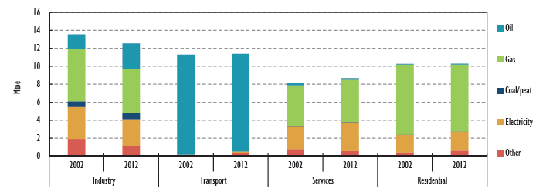
Source: IEA, Energy Efficiency Market Report 2014
Since the start of the millennium, the EU has adopted several measures intended to improve energy efficiency at both the pan-European and national levels. The latest piece of legislation is the said Energy Efficiency Directive, which was finalised by European institutions in 2012.
The EED is supposed to ensure that member states achieve one of the climate and energy targets for 2020. The EU has set itself a 20% energy savings target by 2020 when compared to the projected use of energy in 2020. At an EU summit in October 2014, EU member states agreed on a new energy efficiency target of 27% or greater by 2030. The target of a 20% improvement in energy efficiency by 2020 is one of the 20-20-20 targets (by 2020 cut emissions by 20%, increase the share of renewables in energy generation by 20%, and improve energy efficiency by 20%). The energy efficiency target is the only non-binding target, and estimates suggest that it is the only target member states will fall short of. Yet, the European Commission is convinced that energy savings have great and as yet unused potential and that they are able to satisfy a significant portion of European demand for energy.
If, however, member states were to fully implement the existing legislation, including the EED, the target would be easily achieved and no other regulations would need to be adopted, according to the European Commission.
The deadline for full implementation of the EED in member states was June 2015. However, member states were required to set their own internal indicative and non-binding targets under Article 3 of the EED during 2013. Article 4 of the EED also requires member states to draw up long-term strategies for the renovation of all buildings in their territory. This strategy is meant to show how the member state will set about improving energy efficiency in buildings over the long term. This should create certainty on the market for long-term investments. Article 5 of the EED sets out the exemplar role of public bodies’ buildings. It says that state authorities should lead by example in improving energy efficiency. The article requires each member state to ensure that 3% of the floor area of buildings owned and occupied by its central government is renovated to improve energy efficiency. Historically or architecturally valuable buildings are exempted. Lastly, Article 7 of the EED provides that from January 2014 member states should annually achieve new energy savings of 1.5% of the annual energy sales to final customers.

2.3.2 Energy efficiency in the USA
The USA remains an energy-intensive economy relative to other IEA countries in terms of both GDP and per capita income, owing to its large transport sector (41.7% of total final consumption [TFC]) and its relatively high living standards. TFC has fallen by 8.8% since 2007, mostly as a result of the economic slowdown, but also through the steady diffusion of energy efficiency policies. An important trend for consumers has been the fall in household expenditure on energy consumption. Consumers spent almost 20% less on energy in 2011 than in 2000, a trend that is likely to continue as gas prices remain low and the impacts of energy efficiency policies grow.
Investment in energy efficiency measures by manufacturers, builders and consumers is strongly influenced by policies at both federal and state levels. These policies drive energy efficiency investments in two ways: by compelling spending in order to comply with regulatory requirements (e.g., energy performance standards for buildings and appliances, energy efficiency resource procurement standards for utilities), and by stimulating spending through economic and fiscal policies (e.g., stimulus spending, tax incentives).
The USA has made significant improvements in energy efficiency policies, notably in the areas of vehicle fuel economy and appliance standards, but also in state-level energy efficiency resources standards. These policies are projected to more than treble the estimated 2011 annual site energy savings by 2020. Primary energy savings from these policies would be considerably higher but are not estimated here.
Final consumption of energy
USA’s TFC was 1 432.7 Mtoe in 2012. This level of consumption was 5.9% lower in 2012 than in 2002. The most significant decline was during 2008 and 2009 when TFC fell by 3% and 5.4%, respectively. The transport sector is the largest energy consumer, accounting for 41.7% of TFC in 2012. Around 93% of transportation is fuelled by oil products, with the remainder from biofuels and waste (4.3%), natural gas (2.9%), and electricity (0.1%). The use of biofuels in transport has increased sixfold compared to 2002, while the use of oil products has declined by 4.1% over the same period. Overall energy consumption in transport has remained unchanged compared to 2002.
- Energy efficiency policies and results
Sector and policy | Policy/legislation | 2011 annual site energy savings (TWh) | Forecast annual site energy savings in 2020 (TWh)
Light- and heavy-duty vehicle fuel economy standards | US EPA/NHTSA Joint Rule-makings for 2012-16 and 2017-25. | N/A | 962
Appliance and equipment standards programme | National Appliance Energy Conservation Acts of 1987 and 1988 (NAECA).  Energy Policy Act of 1992 (EPAct 1992). Energy Policy Act of 2005 (EPAct 2005). Energy Independence and Security Act 2007 (EISA). | 400 (242 electric) (156 gas) | 695 (610 from standards in place today; 85 from new standards)
Ratepayer-funded energy efficiency | State-level legislation and regulation establishing energy efficiency resource standards, and savings obligations. | 117.3 (81 electric) (36 gas) | Medium: 210 High: 255
Building codes | State-level residential and commercial building codes. | 64 (37 electric, 26 gas, 0.5 heating oil) | 244 (89 electric, 67 gas, 1.0 heating oil)
Energy services companies (ESCO) industry | EISA, Section 432. American Recovery and Reinvestment Act (ARRA). | 270 | 770
Total |  | 851.3 | 2 926
Note: ASHRAE = American Society of Heating, Refrigerating and Air-Conditioning Engineers; N/A = not applicable; NHTSA = National Highway Traffic Safety Administration; TWh = terawatt hour; US EPA = United States Environmental Protection Agency. IECC = International Energy Conservation Code.
Source: IEA, Energy Policies of IEA Countries – The United States 2014 Review
Institutions
Generally, the federal government is directly responsible for energy efficiency policies affecting appliances and equipment, and vehicles (some state policies and standards beyond the national ones exist). Appliance and equipment standards are promulgated by the Department of Energy (DOE) while the Environmental Protection Agency (EPA) and Department of Transportation share responsibility for light- and heavy-duty vehicle fuel economy standards. State energy offices and state regulators are responsible for energy efficiency resource standards placed on gas and electric utilities. The federal government has no direct responsibility regarding energy efficiency policies for buildings and retail energy providers. Nonetheless, DOE plays an important supporting role in building the capacity of state regulators, legislators, and energy offices to consider and implement energy efficiency policies. Both the federal and state governments employ economic and fiscal policies to promote energy efficiency investment.
Assessment by the IEA
The USA has made significant progress with implementing energy efficiency policies according to the IEA. The country is a leader in facilitating private-sector energy efficiency investments. A 2009 economic stimulus package included new energy efficiency initiatives and substantial additional funding for existing programmes. The direct and indirect funding for these programmes totalled more than USD 30 billion, five times more than 2008 funding levels.
The country is on track to become one of IEA’s most energy-efficient countries by 2020. Energy efficiency improvements will continue to unfold over the medium term, as energy efficiency improvement targets for vehicles, appliances and equipment, and new buildings are implemented. These regulatory policies will be supplemented by continued modest growth in ratepayer-funded energy efficiency and the ESCO industry. Tax incentives could provide an additional stimulus to energy efficiency spending by households and businesses. In the aggregate, these policies have the potential to triple annual savings from energy efficiency between 2012 and 2020. Some analysts even predict lower demand for gas, electricity and transport fuels in the coming years as a result of this energy efficiency scaling-up.
- Actual and forecast annual savings from energy efficiency policies and markets, 2011 and 2020
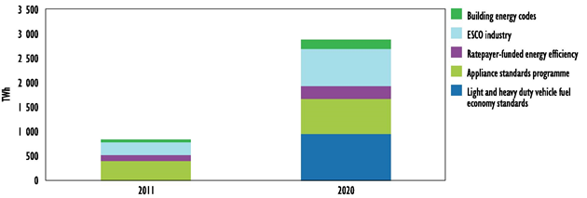Source: Energy Policies of IEA Countries – The United States 2014 Review
A realistic outlook on energy efficiency in the USA, however, needs to take into account the potential obstacles to continued steady growth. There are concerns about whether spending on energy efficiency can be sustained, especially in light of the downward pressure on public budgets and continued low natural gas prices. There are concerns that the delivery capability of the energy efficiency industry may not be able to keep up with ambitious targets for savings and efficiency improvements. Delays in technology development could result in downward adjustments in appliance standards or vehicle fuel economy improvement targets.
Based on the INTOSAI WGEA survey results, we have gained information about tools that are used in the USA to support better energy savings and/or energy efficiency.
Consumer products:
• Energy efficiency standards: Adopting minimum energy efficiency standards that establish a national minimum level of energy efficiency for selected categories of products and are designed to eliminate the least efficient products from the marketplace. These standards currently apply to 33 categories of products, including refrigerators and dishwashers.
• Energy Guide: Requiring information be displayed on a label attached to selected products that enables consumers to compare the estimated energy cost and energy consumption of different models within a given product category (such as televisions and dishwashers).
• Energy STAR: Identifying the most energy efficient models within a given category of products. Manufacturers of qualifying products can display an Energy Star label on their products that is widely recognized by buyers as an indication of energy efficiency. The programme also encourages manufacturers to improve energy efficiency of some models so that those models qualify for the Energy Star label. This programme covers 37 such product categories, including televisions and washing machines.
• Corporate Average Fleet Efficiency Standards (CAFE): These standards apply to the nation’s motor vehicle fleet and require average fleet fuel efficiency to increase over time. The Department of Transportation is primarily responsible for setting and enforcing CAFE standards for cars and light trucks, although the EPA and the DOE are also involved. New standards set in 2012 require automakers to raise the average fuel efficiency of new cars and trucks to 54.5 miles per gallon by 2025.
• Advanced Technology Vehicle Manufacturing Program: This is part of the Department of Energy’s Loan Programs Office. It provides for loans and grants to eligible automobile manufacturers and component suppliers for projects that reequip, expand, and establish manufacturing facilities in the USA to produce light-duty vehicles and provide improvements in fuel economy performance beyond certain specified levels.
• Electricity Demand Response Programs: Largely administered by regions, states, or localities, these programmes provide incentives for users of electricity to reduce their use during peak demand periods, thereby reducing the cost of providing electricity.
Energy efficiency improvements in buildings:
• Energy Savings Performance Contracts: These are financing mechanisms that federal government agencies can use, in which private sector companies pay for and manage energy efficiency upgrades to buildings and facilities and receive compensation from the resulting energy savings.
• Green Building Codes: The LEED - Green Building Rating System is a nationally accepted benchmark for the design, construction, and operation of high performance green buildings.
• The DOE also has several broad national programmes that support energy efficiency improvements in buildings:
o Research partnerships with industry and academia to advance building science and improve technologies and practices that make both residential and commercial buildings more energy efficient.
o DOE federal–state partnership projects help implement training programmes and provide technical assistance and education that is intended to ultimately result in the construction of more energy efficient buildings.
o The DOE administers a Weatherization Assistance Program that enables low-income families to permanently reduce their energy bills by making their homes more energy efficient.

2.3.3 Energy efficiency in China
As the world’s largest energy consumer, China is also home to one of the most active energy efficiency service and investment markets in the world. Improving energy efficiency in the industrial sector is a priority for government policy. Government policies include a variety of administrative programmes, such as mandatory energy savings agreements with all large and medium-sized enterprises. Policies and programmes also promote a series of market-based initiatives.
Energy efficiency market activity: investment over the 11th Five-Year Plan (FYP) period 2006 - 2010
The 11th FYP heralded energy efficiency as a means to advance social and economic development, targeting 20% reduction in energy intensity over the five-year period against the 2005 baseline. Key elements in the plan included the Ten Key Projects, the 1 000 Industries Programme and the Obsolete Capacity (Small Plant) Closure programme. In addition, appliance standards and labelling programmes were strengthened, and enforcement of new building codes implemented.
- Summary of investments in programmes within the 11th FYP
Policies | Government investment | Energy demand reduction | Value of avoided demand/other market value
Ten Key Energy Conservation Projects | CNY 30 billion | 238 Mtoe (340 Mtce) by 2010 | -
1000 Enterprise Programme | CNY 50 billion | 26.7 Mtoe (38.2 Mtce) in 2007; 115.5 Mtoe (165 Mtce) total by 2010 | -
Energy Efficient Product Discount Scheme; 34 million high-efficiency air conditioners (2009-10)* | CNY 11.5 billion | 0.86 Mtoe/yr (10 TWh/yr); 6.88 Mtoe to 8.60 Mtoe (80 TWh to 100 TWh) lifetime; 30% reduction in peak energy demand | CNY 5 billion/yr; CNY 40 billion to CNY; 50 billion lifetime
Energy Efficient Product Discount Scheme; 360 million CFLs (2008-10) | CNY 2 billion | 1.33 Mtoe/yr (15.5 TWh/yr) | CNY 8 billion lifetime
Shift small car market share from 7% to 30% (1 million cars < 1.6L) | CNY 3.04 billion | 0.3 Mtoe/yr; 4.5 Mtoe to 6 Mtoe lifetime | -
Development of Energy Conservation Industry (984 certified ESCOs) | CNY 180 billion | 9.1 Mtoe/yr (form base of 0.42 Mtoe/yr) (13 Mtce/yr [form base of 0.6 Mtce/yr]) | Market value: CNY 4.7 billion to CNY 84 billion (2006-10); Investment growth: CNY 1.3 billion to CNY 29 billion (2206-10)
Obsolete capacity retirement programme | - | 82.6 Mtoe by 2010 (118 Mtce by 2010) | -
* Seven product classes were included in this scheme: light bulbs, air conditioners, flat panel televisions, washing machines, water heaters, refrigerators, and personal computers.
Notes: Some double counting may exist (for example enterprises listed in the Thousand enterprise Programme could apply for funding through the Ten Key Projects, and the result could be attributed to both programmes).
Source: IEA, Energy Efficiency Market Report 2013
Table 5 presents investments and outcomes from energy efficiency programmes under the 11th FYP. Note that the investment data cover a limited period of the programme and as such may undervalue the total investments made.
By 2010, China had achieved a 19% reduction in energy intensity from the 2005 level, equivalent to a reduction in energy demand of 630 million Mtoe.
The 11th FYP saw an estimated cumulative investment of CNY 859 trillion in energy efficiency, approximately 15% of which came from central and local governments, and 85% from commercial banks, host enterprises or ESCOs, most of them state-owned (Climate Policy Initiative, 2012). The industrial sector represented the largest share of investments, at 64%, followed by the building sector at 30%. Direct government spending and bank loans were the primary sources of financing.
Energy profile
China’s total energy use is the highest of any country in the world. According to Chinese energy balances, total primary energy supply (TPES) more than doubled between 2001 and 2012, reaching 2 532 Mtoe – about one-fifth of the world total in 2012. Total final energy consumption grew to 1 702 Mtoe in 2012. This strong increase was driven by even faster economic growth.
- TPES, TFC, electricity consumption, energy intensity and energy use per capita in China, 2002-12
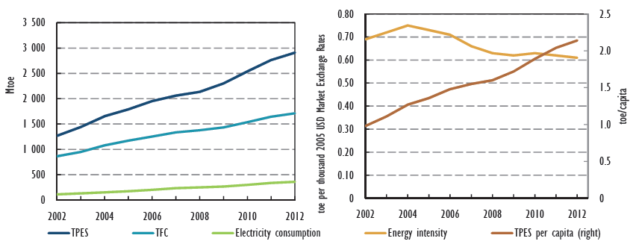
Note: toe = tonnes of oil-equivalent.
Source: IEA, Energy Efficiency Market Report 2014
As shown in Graph 7, the intensity of China’s energy use per unit of GDP rose between 2002 and 2004, but then fell every year between 2005 and 2012, with a reduction of over 30% during that period.
Overview of China’s energy efficiency investment during the 11th and 12th FYP
The industrial sector accounted for the bulk of energy efficiency investment (77%) during the 11th FYP. Energy efficiency investment in buildings and transport accounted for 12% and 6% of the total, respectively. The share of industry in total energy efficiency investment is expected to fall during the 12th FYP in favour of other sectors, but experts continue to debate by how much. Some predict a dramatic shift in the share of investment from industry to buildings and capacity building.
- China’s energy efficiency investment by sector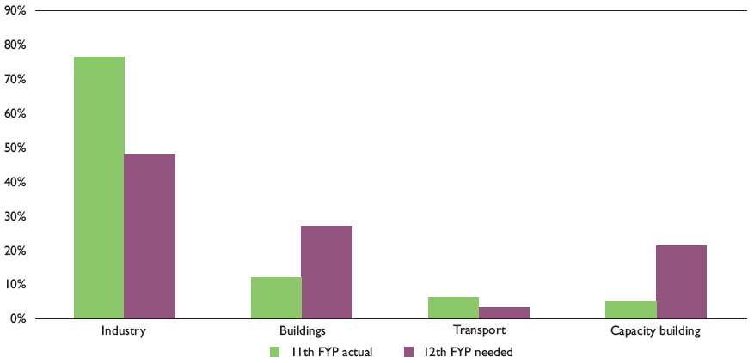
Notes: The industrial sector mainly includes investment in technical renovation and elimination of obsolete capacity; the building sector mainly includes investment in technical renovation and government oversight; the transport sector mainly includes investment in modal shift; and investment in capacity building mainly includes technical research, institutional capacity building, promotion of energy-efficient technology, etc.
Source: IEA, Energy Efficiency Market Report 2014

2.3.4 Energy efficiency in Africa
Africa is rich in energy resources, but very poor in energy supply. The IEA´s reports show, for example, that in sub-Saharan Africa only 290 million out of 915 million people have access to electricity and the total number without access is rising. A great shortage of essential electricity infrastructure is undermining efforts to achieve more rapid social and economic development. Electricity tariffs are, in many cases, among the highest in the world and, outside South Africa, losses in poorly maintained transmission and distribution networks are double the world average.
Around 80% of residential energy demand in sub-Saharan Africa is for cooking, compared with around 5% in OECD countries. This is mainly due to households prioritising energy for cooking (and lighting) within very restrictive budgets (when paid for) and the low efficiency of the cookstoves used (typically 10-15% efficiency for a three-stone fire, compared to 55% for an LPG cookstove).
According to IEA, Nigeria becomes the unrivalled centre of energy demand, almost doubling to more than 250 Mtoe in 2040. Over the projection period, Nigeria continues to account for one-quarter of total sub-Saharan demand. Other countries in West Africa see their collective demand double by 2040, but this collective demand is still lower than that of Nigeria today. Central Africa, which is home to 12% of the sub-Saharan population, accounts for only 7% of energy demand today and this share increases only marginally (to 8%), despite annual demand growth of 2.8%. Energy demand in East Africa grows by 2.6% per year, to reach around 230 Mtoe in 2040. Half of this increase is the result of an expansion of electricity supply to meet increasing demand. Southern Africa led by South Africa, Mozambique, and Tanzania, experiences the second-largest energy demand growth of any sub-region (behind West Africa). Across Mozambique and Tanzania, demand growth is particularly strong, increasing by an annual average of 3.7%, driven by strong economic growth that is in part due to new gas and coal production.
According to WEO 2014, energy efficiency is still an underutilised resource: about 60% of the global potential in industry is not realised. In a supply constrained continent, like Africa, energy efficiency has a part to play in making energy more accessible. Some barriers in Africa are the same as those in developed countries; some are not:
- Irregularity of supply of electricity and other forms of energy – Widening access to a reliable supply of energy is a principal objective for many in Africa. One obstacle is that the supply of electricity and other forms of energy tends to be irregular, leading to interruptions of production and to the use of inefficient standby power systems, e.g., diesel generators. Concerns over the reliability of supply tend to outweigh considerations about how to use energy more efficiently as the potential losses from power outages are much higher than the possible gains from efficiency savings.
- Lack of information about energy efficient technologies is another problem in Africa. Energy efficiency labels are in place in only few countries, energy consumption is often not adequately measured because of a lack of metering equipment, and the public dissemination of information about energy efficiency is limited. These circumstances make any search for information about energy efficiency costly, leaving many companies with old and outdated technology.
- A lack of financing is another major impediment to energy efficiency investments in Africa. Energy efficiency projects sometimes require a substantial upfront investment which is later recovered through energy savings. Investments in new technologies are perceived as particularly risky and the technical capacity to evaluate the opportunities associated with such investments is limited. Moreover, the cost of capital in Africa is much higher than that in most developed countries, which leads to a requirement for unrealistically short payback periods.

On the other hand, also in Africa they are starting programmes to improve efficiency. For example in transport field, policy efforts are increasing, with Nigeria and South Africa being among the first countries in the region to adopt Euro 2 emissions standards. Angola, Botswana and Kenya are examples of countries that have introduced import restrictions on vehicle age. Some countries have introduced fuel quality standards, although poor fuel quality can reduce vehicle efficiency, even where such standards exist. This is an opportunity not only for job creation and growth, but it could provide stronger grounds upon which to introduce and to enforce stricter fuel-economy standards.
Concrete examples of energy policies and targets in sub-Saharan Africa are according to Africa Energy Outlook 2014 by IEA for example:
Table 6 Selected energy policies and targets in sub-Saharan Africa in the fields of energy efficiency
Country | Sector | Policies and targets
Ghana | Efficiency | Reduce transmission losses to 18% by 2018. Standards and labels in place for lighting and air conditioners.
Kenya | Efficiency | Standards for electrical appliances; energy efficiency obligations for utilities. Energy Bill 2014 provides for the creation of an Energy Efficiency and Conservation Agency to enforce energy efficiency standards.
Source: IEA, Africa Energy Outlook 2014

2.4 Indicators for measuring energy efficiency
From the point of view of audit institutions, energy efficiency indicators are an important criterion when assessing the implementation of policies/programmes. The way these indicators are set up is fundamental for assessing economy, efficiency, and effectiveness.
The IEA has operated an international database of energy indicators since 1997. These indicators are intended to be used to study developments in the use of energy and to analyse the factors influencing changes in energy use and CO₂ emissions. These indicators can reveal key links between energy use, energy prices, and economic activity. This is important when assessing and monitoring past and present energy policies and when designing effective future measures and activities.
Energy efficiency indicators by IEA are an important tool for analysing the interactions among economic and human activity, energy use, and CO₂ emissions. Many IEA member countries already employ energy indicators, a set of disaggregated measures of how energy is used.
The following sources may be of importance for auditors:
- World energy council; Energy Efficiency Indicators database:
http://www.worldenergy.org/data/efficiency-indicators/;
- IEA energy efficiency indicators: https://www.iea.org/topics/energyefficiency/subtopics/energyefficiencyindicators/;
- The EU database of indicators – ODYSSEE: http://www.odyssee-mure.eu/.
It has emerged from the public sources, from the INTOSAI WGEA survey, and from audits performed by SAIs that countries and SAIs use various indicators to assess individual tools. Generally, we can say that SAIs use in their audits indicators for policies evaluation set by governments, but they can also use their own indicators for this evaluation.
58 INTOSAI WGEA members have completed and sent back the survey, which represents 77% of all respondents. The survey results show that 48 of questioned countries use tools for energy savings and 32 INTOSAI WGEA members state that there are set or defined indicators for energy savings in their country. Also, it follows from the project survey that only a small number of SAIs (14 members of the INTOSAI WGEA) have focused their audits on energy efficiency or energy savings topic in the last five years.

- Two types of indicators that are used to assess measures for energy savings and/or energy efficiency support:
Indicators as performance evaluation criteria in audits

Energy efficiency indicators are useful for the creators of policies/programmes when seeking to evaluate measures and areas where energy savings can be achieved.

List of several targets and indicators used by SAIs that have followed from the INTOSAI WGEA survey:
Australia
The principal indicator is C0₂ savings. However, action plans estimate energy savings from potential investments and cost according to energy prices in order to determine if/when an investment is cost neutral.
New South Wells
The overall goal of the energy efficiency action plan is to tackle the costs of living in New South Wales, and achieve the following targets:
- achieve 16,000 GWh in energy savings per year by 2020;
- support 220,000 low income households to reduce energy use by up to 20% by 2014;
- assist 50% of New South Wells commercial floor space achieve a four-star NABERS energy and water rating by 2020, through the delivery of high-standard building retrofit programmes.
Canada
Federal government has a well-defined set of indicators that it uses for tracking and reporting energy use and energy efficiency. See the website for Natural Resources Canada, the lead federal department for energy efficiency: http://www.nrcan.gc.ca/energy/efficiency (also available in French).
For the statistics and analysis, see: http://oee.nrcan.gc.ca/corporate/statistics/neud/dpa/home.cfm.
Costa Rica
The energy efficiency indicators measured by the Ministry of Environment and Energy are: intensity of commercial energy, commercial energy consumption per capita, intensity of oil consumption, intensity of consumption of electricity, residential electricity consumption per capita, electric intensity of the industrial sector, electric intensity of the commercial and service sector, and unit consumption of road transport. The last four indicators are long-term goals in the VI National Energy Plan.
European Court of Auditors
The European Commission in its technical guidance on Financing the energy renovation of buildings with Cohesion Policy funding (2014) proposed number of indicators for investments within Operational Programmes supporting energy efficiency (e.g., number of households with improved energy consumption classification, number of buildings in the two lowest energy performance classes, decrease of annual primary energy consumption of public buildings, and number of additional energy users connected to smart grids).
Finland
Saving energy Wh/year, saving %, Wh/m³, maintenance costs/m³, maintenance costs/building, water consumption/day, water consumption/person.
Jordan
National Energy Action Plan of Jordan depends on the key indicators of the Jordanian electricity consumption to set its targets. For instance: it stated that the electricity intensity in Jordan was 1.13 GWh/GDP in 2010 and is forecasted to reach 1.28 GWh/GDP in 2020.
Malta
Set indicators for measuring energy savings and energy efficiency in relation to various sectors are indicated in the document published by the Malta Resources Authority entitled: Energy Efficiency Policies and Measures in Malta. The document is available at: http://www.odyssee-mure.eu/publications/national-reports/energy-efficiency-malta.pdf.
New Zealand
The Energy Efficiency and Conservation Authority (EECA) has a set of indicators that it measures progress against. The measures relate to EECA’s programmes, such as providing funding for better home insulation, improving energy intensity (see below), and that an increased proportion of energy is supplied from renewable resources.
For more information see EECA’s 2013 annual report (page 29 and following), and the description of the energy intensity measure – see: http://www.eeca.govt.nz/resource/eeca-annual-report-2013.
One of the key measures in the NZEECS of the longer term view of the progress New Zealand is making in energy efficiency and conservation is energy intensity, or the energy used per unit of GDP.
Norway
Norway is a part of the ODYSSEE network in Europe. ODYSSEE is a database that contains detailed data on the energy consumption drivers by end-use and, on the other hand, energy efficiency and CO₂ related indicators. Data is regularly updated by national representatives, such as energy agencies or statistical organization, from all 28 EU member states as well as Norway. Currently, energy efficiency data is available from the year 1990 to 2011. The database includes indicators on overall energy efficiency and consumption as well as indicators mapping energy efficiency in industry, transport, households, services, etc. It also contains information on energy drivers like heated square meters in the households and services sectors, transported passenger-km and ton-km of goods, value added, production index, production volumes, etc.
Philippines
The Department of Energy has mechanical devices/indicators and installed those devices in the retrofitted buildings and street lights. It has also developed methods of computing the energy savings and efficiency.
Poland
Indicators of the Central Statistical Office: total use of primary energy; final use of energy; final energy use with climate adjustment; primary energy consumption GDP; final energy consumption GDP with the climate adjustment; energy consumption of the industry with the division into sectors: food, textile, forestry, paper, chemical, mineral, mill, machine, transport; energy consumption of production with the division into: steel, cement, paper; use per 1 dwelling unit, use per 1 dwelling unit with the climate adjustment; total use per 1m²; use for heating per 1m²; use of electric energy per 1 dwelling unit; indicators of energy efficiency in the sector of services; indicators of energy efficiency in transport and power engineering; indicator of energy efficiency ODEX.
Tanzania
Tanzania uses the following indicators:
a) Energy consumption reduction;
b) Energy cost savings;
c) Reduced energy demand and supply gap;
d) Reduced Carbon foot print.
USA
Federal statutes and executive orders specify numerical and other targets for federal agencies regarding their facility and fleet energy savings, energy efficiency, and other green goals. The Administration tracks and publicly reports on individual agencies’ compliance in meeting the targets. Some examples of targets:
- Reduce petroleum consumption by 2% per year through FY2020 (applies to agencies with fleets of more than 20 vehicles) (Baseline FY2005);
- Reduce by 2% annually:
- Potable water intensity by FY2020 (26% total reduction) (Baseline FY2007);
- Industrial, landscaping, and agricultural water intensity by FY2020 (20% total reduction) (Baseline FY2010).
- Increase renewable energy and renewable energy generation on agency property;
- Ensure all new Federal buildings that enter the planning process in 2020 and thereafter are designed to achieve zero-net-energy standards by 2030;
- Use low greenhouse gas emitting vehicles, including alternative fuel vehicles, and optimize the number of vehicles in agency fleets.

Chapter 3 - Auditing energy savings issues (INTOSAI community experience)
The case studies presented in this section are based on audits conducted by SAIs from all over the world and their common topic/subtopic is energy savings, or energy efficiency respectively.
The purpose of this chapter is to gather qualitative information about best practices and knowledge of the INTOSAI WGEA community in auditing energy savings projects, methodology, challenges related to performing such an audit, and audit findings. This could be achieved through the use of illustrative case studies. The aim of this study is to give examples of best practices and disseminate the audit work of other SAIs in this area.
Based on the case studies analysis, we have identified the following challenges for SAIs:
- lack of base data required for efficient planning of energy savings and energy efficiency;
- improvement in risk analyses (proper identification of potential risks);
- identification of barriers to investments created by current economic conditions;
- cost-effectiveness of programmes/projects - establishing and application of cost-effectiveness criteria adapted to projects’ circumstances;
- unclear results of and improvements in energy efficiency area; problems with quantification of savings – whether the set goals and energy savings were reached; whether the tools achieved its intended impacts;
- reports on effects of measures for energy efficiency in a coordinated and clear way;
- monitoring/prevention of fragmentation and overlapping of programmes to prevent duplication of funding;
- in audits, monitoring project performance and reporting on whether programme objectives are being achieved;
- control and management of risks with respect to large grants and new technology; higher efficiency of control mechanisms.

Title | Administration of Climate Change Programs
Country and year of publication | Australia, 2010
Type of audit | Performance audit
Audit objective | The objective of this audit was to assess the effectiveness of the Administration of specific climate change programs by the DEWHA and the Department of Resources, Energy and Tourism (DRET).
Audit scope | The audit scope included four programs managed by DEWHA. In March 2010, responsibility for these programs was transferred to DCCEE. These programs included two competitive grant programs and two rebate schemes. One competitive grant program was managed through DRET.
Audit criteria | The audit followed four lines of inquiry:  - development of program objectives and assessment of program risks;  - assessment and approval of competitive grant applications;  - assessment and approval of rebate applications; and  - measurement and reporting of program outcomes.
Methods used | Review of the grant and rebate programs, program achievements.
Findings | Each program had different administrative issues and challenges and the effectiveness of some of these programs was constrained by weaknesses in program implementation and design.  The objectives of the five climate change programs were generally broad, with three of the five programs having multiple objectives. These three programs had very little specificity in terms of how much was intended to be achieved over the life of the program, making it difficult to target resources and set administrative priorities.  The control and management of risks could have been substantially improved. The nature of the programs examined, involving large grants and new or unproven technology, meant that they were inherently high risk. However, where programs had undertaken risk assessments, the treatment options or controls did not always mitigate the risks identified, and many of these risks materialised throughout the course of programs.  Across the five programs examined, performance reporting could have been substantially better in terms of accuracy and consistency. If Parliament is to make informed judgements about what these, (and any future climate change programs) have achieved, reporting by agencies will need to more closely adhere to the annual reporting guidelines. In particular, reporting actual performance in relation to performance targets; and providing narrative discussion and analysis of performance.
Recommendation | In order to strengthen the consistency and core competencies in grant administration, the Australian National Audit Office recommends that the DEWHA and the DCCEE give priority to establishing a Grants Policy Unit to facilitate consistent practice across the department in terms of:  (a) identifying and managing risk throughout the lifecycle of a program;  (b) assessing and selecting projects that represent value for money and meet program objectives and criteria; and  (c) monitoring project performance and reporting on whether program objectives are being achieved.

Title | Design and Implementation of the Energy Efficiency Information Grants Program (EEIG program)
Country and year of publication | Australia, 2013
Type of audit | Performance audit
Audit objective | The objective of the audit was to assess the effectiveness of the design and implementation of the EEIG program. The focus of the audit was the preparation for, and conducts of, the first funding round of the program.  The objective of the Energy Efficiency Information Grants program is to empower SMEs and community organisations to make informed decisions about energy efficiency. It is to achieve this objective by funding industry associations and non‐profit organisations to deliver practical and tailored energy efficiency information to help SMEs and community organisations respond to the impact of increasing energy costs.
Audit scope | The audit scope covered the key elements of the EEIG program, from the planning phase of the program to the signing of funding agreements with successful applicants and the provision of feedback to unsuccessful applicants. The audit did not examine Department of Climate Change and Energy Efficiency´s (DCCEE) oversight of the delivery of funded projects.
Audit criteria | In particular, the audit examined whether:  - the advice provided by DCCEE in the design and implementation of the EEIG was accurate and complete;  - applications were assessed in terms of their eligibility and comparative merit against the criteria published in the program guidelines;  - sound funding agreements were developed and signed in a timely way with the successful applicants; and  - unsuccessful applicants were provided with appropriate feedback.
Methods used | N/A
Findings | The Green Loans program was designed to help make existing homes greener and more energy and water-efficient. The funding allocated to the Green Loans program (originally $300 million but later reduced to $174.4 million) was significantly less than some of Department of the Environment, Water, Heritage and the Arts´ (DEWHA) other environmental initiatives, but the program's impact on stakeholders, particularly assessors, was extensive. The program stimulated a small sustainability assessment industry and created work for thousands of assessors. Hundreds of thousands of households had their energy and water consumption assessed to identify opportunities for making savings. The assessment reports informed householders how to change their behaviour (for example, by lowering hot water system thermostat settings), and householders could apply for an interest-free loan to fund the purchase of capital items to improve their home's environmental sustainability.
Recommendation | The audit has not made any recommendations to the departments as DEWHA and DCCEE announced changes to improve corporate and program governance, enhance internal control mechanisms and systems, and strengthen accountability frameworks. Better engagement of centrally maintained subject matter expertise, such as risk management, procurement, ICT, compliance and communications, by program areas is also being encouraged to provide greater support for program managers.

Title | Activities of the state in achieving energy conservation
Country and year of publication | Estonia, 2009
Type of audit | Performance audit
Audit objective | “Can Estonia save 2 678 GWh of energy by 2016?”
Audit scope | The National Audit Office assessed in its audit whether or not the state has a clearly agreed action plan for more economical use of energy. We also analysed the implementation of energy conservation principles in the public sector and focused mainly on the activities of the state in purchasing energy efficient equipment and vehicles and construction of public buildings.
Audit criteria | The Ministry of Economic Affairs and Communications prepared the Specific Research Programme of Energy Conservation for 2007 to 2013 in order to restrict energy consumption and it contains 17 energy conservation measures costing a total of 1.63 billion kroons (104.18 million euro*). According to the specific research programme, the citizens, companies and state institutions of Estonia should have saved 1 785 GWh from 2008 to 2013. This is the quantity of electric energy consumed by Estonian households within one year, which costs them 2.6 billion kroons (166.17 million euro*).
Methods used | N/A
Findings | It is not known where and how much energy will be saved as a result. The specific research programme of energy conservation does not set any clear and measurable energy conservation goals or deadlines. The energy saved as a result of the measures offered by the specific research programme cannot be reliably measured, because the measures are not tied to measurable energy conservation results.  The state is too focused on explaining why energy conservation is necessary and offering monetary support to citizens and companies has remained in the background. The specific research programme of energy conservation focuses mainly on research, preparation of legal acts, training, and improving the distribution of information.  No person who would be responsible for the implementation of the principles of energy conservation has been appointed in the public sector. Millions of euros are spent on acquiring buildings, vehicles and office equipment in public procurements, energy conservation has remained in the background in determining the best offers. Little attention is paid to justifying energy costs in the management of public buildings, because the data needed for analysing and planning conservation measures is not collected.  Estonia does not have the base data required for efficient planning of energy conservation.
Recommendation | N/A
* Calculation according to official rate for the changeover from kroon to euro, which was 15.6466 EEK for 1 euro.

Title | COST-EFFECTIVENESS OF COHESION POLICY INVESTMENTS IN ENERGY EFFICIENCY
Country and year of publication | European Court of Auditors, 2012
Type of audit | Performance audit
Audit objective | The European Court of Auditors assessed whether Cohesion Policy investments in energy efficiency were cost-effective. To answer this question, the Court asked whether:  (a) the right conditions in programming and financing had been set to enable cost-effective energy efficiency investments; and whether  (b) energy efficiency projects in public buildings were cost-effective.
Audit scope | The audit was carried out in the Czech Republic, Italy, and Lithuania — the countries that had received the largest contributions from the Cohesion Fund and European Regional Development Fund for energy efficiency measures for the 2007–13 programming period and had also allocated the highest amounts to projects by 2009. By the end of 2011, these countries had allocated 1 199,3 million euro to energy efficiency projects under their respective operational programmes 33 % of the total amount of projects selected at that time under the Cohesion Policy funds allocated to energy efficiency in the 2007–13 programming period.  The audit included an examination of four operational programmes and a sample of 24 energy efficiency investment projects in public buildings.
Audit criteria | Audit criteria developed for  (a) project implementation and  (b) cost-effectiveness
Methods used | Answering the question on programming and financing involved analysing the relevant operational programmes, their ex ante evaluations and the prioritisation of the energy efficiency policy at national level and within individual economic sectors. It also required an analysis of the achievement of national energy efficiency targets and the impact of the Cohesion Policy funds on this achievement, the availability of national and private co-funding, and a review of other national financial support mechanisms.
Findings | I. Planning and financing  Operational programmes were not based on proper needs assessments;  Cost-effectiveness was not a determining factor when allocating funding to energy efficiency measures;  Weaknesses in project selection criteria;  Inadequate performance indicators and monitoring;  II. Implementation of public buildings projects  Energy efficiency was not the main objective;  Energy audits were not always obligatory or not of good quality;  Projects produced physical outputs, but at a high cost in relation to the energy potentially saved.
Recommendation | I. Commission  Ensure future Cohesion policy funded renewable energy resources (RES) generation programmes are cost-effective;  Promote stable and predictable regulatory framework for RES in the Member States, including for RES electricity grid integration.  II. Member States  Establish and apply cost-effectiveness criteria adapted to projects’ circumstances;  Enhance EU added value of Cohesion Policy funds through improving RES project implementation, monitoring and evaluation as well as through building up RES data.

Title | Energy saving investments in public utility buildings
Country and year of publication | Poland, 2015
Type of audit | Performance audit
Audit objective | The main goal of the audit was the assessment of energy and cost savings effects of investments which was carried on under the programme of energy efficiency. The assessment focused on the criteria of economy, efficiency, and effectiveness of used resources.  The next particular aims were the assessment:  - If the competition procedure and selecting process favoured the buildings and investments projects which had the highest potential of energy and economy savings;  - If the management of the control process of energy saving investments assured that the modernization of buildings was carried on in the most economical, efficient, and effective way;  - If the scheme of measuring the energy and economy effects was credible and contributed to improving the effectiveness of the national energy efficiency policy.
Audit scope | Auditees: the National Fund for Environmental Protection and Water Management (NFEPWM; the leader of the system of financing for environmental protection and water management in Poland) and 14 beneficiaries who carried on 15 investment projects.  The audit dealt with two parts of the priority programme of energy management in public service buildings. The thermal modernization of buildings and replacement of internal lighting for energy-efficient one were financed by NFEPWM from the proceeds from the sale of assigned emission credits (subsidies from the Green Investment Scheme) or other funds of the NFEPWM. The audited period was 2010-2014.
Audit criteria | - the national energy efficiency policy;  - the contracts of selling the assigned emission credits;  - the priority programme of NFEPWM: part 1 Energy management in public service buildings and part 5 Energy management in buildings of selected public sector entities;  - the contracts on co-financing by the funds from the Climate Account;  - the energy audits.
Methods used | - interviews;  - study and analysis of documents;  - cross-checking;  - data method: qualitative, quantitative, and comparative analysis.
Findings | The energy savings investments fulfilled the main objective of the programme which was reducing or avoiding carbon dioxide emissions by co-financing projects that improve energy efficiency in public service buildings. The thermal modernizations of buildings were performed in the most economical and effective way. The effects of the modernization projects were the savings of energy. Consequently, the costs of maintaining buildings were lower than in the period before the investment.
Recommendation | Recommendations to the NFEPWM:  - improve the competition procedure and selecting process in a way that will form the best relationship between resources employed and results achieved;  - the competition procedures should stimulate innovative, non-standard projects that will be the most cost-effective;  - improve arrangements for calls, especially the term of a call should be shorter and the quality of selecting should be better;  - improve the management of the control process of energy saving investments;  - improve the communication with beneficiaries;  - the methodology of measuring energy consumption should be easier to understand for beneficiaries.  Recommendations to the beneficiaries:  - improve the internal control process of measuring and maintaining energy savings after modernization.

Title | Fulfilment of tasks of the Slovak Republic in ensuring of energy savings
Country and year of publication | Slovakia, 2015
Type of audit | Compliance audit
Audit objective | The Supreme audit office has audited three ministries and three state organisations responsible for implementation of measures/recommendations related to energy savings. Audits assessed implementation of EU regulations concerning energy savings to national law, the administrative instruments used in the public sector to achieve the energy savings goals.
Audit scope | Slovak government has adopted the Concept of Energy Efficiency of the Slovak Republic, which defined an overall national indicative energy savings target for the period 2008 - 2016 amounting to 9% of the average final energy consumption from the years 2001-2005, i.e. 37 215 terajoules. Concept of Energy Effectiveness is realized in particular through three-year action plans for energy efficiency.
Audit criteria | Directive 2006/32/EC of the European Parliament and of the Council of 5 April 2006 on energy end-use efficiency and energy services  Directive 2012/27/EU of the European Parliament and of the Council of 25 October 2012 on energy efficiency  The Concept of Energy Efficiency
Methods used | N/A
Findings | - All directives of the European Parliament and Council relating to energy efficiency have been implemented into Slovak law.  - In previous years, Slovakia has breached its duty to provide the annual renewal of 3% of the total floor area of heating and cooling buildings owned and used by central government bodies.  - Sources of energy savings funding are fragmented and uncoordinated.  - The system-based mechanism of energy efficiency support was not established.  - To achieve energy saving policy goals the state should systematically utilise sources of proceeds from emissions trading schemes and revenues from excise duties on electricity, coal and natural gas.  - Sources of funding for compulsory reconstruction of buildings of state administration for the years 2014 – 2020 are insufficient.  - Lack of staff dealing with issues of energy savings agenda within the central state administration bodies.  - The method of monitoring and evaluation measures of energy efficiency is complicated and incomplete.
Recommendation | N/A

Title | Energy efficiency in industry – effects of central  government action RiR 2013:8
Country and year of publication | Sweden, 2013
Type of audit | Performance audit
Audit objective | The Swedish National Audit Office has audited central government action on improving energy efficiency in industry, with a special focus on the voluntary Programme for improving energy efficiency in energy intensive industries (PFE). At a more general level, the Swedish National Audit Office also examined whether policy instruments for energy efficiency in industry, including the PFE, contribute to reducing emissions in the short and long term, nationally and at EU level.
Audit scope | The audit covers central government measures for energy efficiency improvement in industry, in particular the voluntary programme for improving energy efficiency (PFE). The audit also deals with the issue whether energy efficiency in industry contributes to emissions reduction, in the long and short term, nationally and at EU level. The electricity certificate system is also touched on in these contexts.
Audit criteria | - How much energy efficiency the PFE has contributed to;  - Energy consumption – PFE companies compared with other companies;  - Reports of The Swedish Energy Agency;  - The PFE companies' investments in electricity efficiency.
Methods used | Counterfactual analyses
Findings | Unclear energy efficiency improvements; The PFE companies' investments in electricity efficiency are approximately the same as the tax relief; The Swedish Energy Agency has not reported the effects of the PFE clearly; Energy consumption in PFE companies has not decreased more than in other companies.
Recommendation | Recommendations to the Government  If the Government proposes that the Riksdag (Swedish Parliament) introduces a new voluntary programme to achieve energy efficiency, the Government should consider:  – determining quantified objectives for such a programme;  – imposing requirements for further energy efficiency improvement for the companies that have already participated in the PFE;  – ensuring specification of the grounds on which companies that do not meet the energy efficiency requirements can be excluded from the programme.  Recommendations to the Swedish Energy Agency  - The Swedish Energy Agency should improve its analyses and reporting of the PFE and clarify the companies’ reporting requirements within the programme.  - The Swedish Energy Agency should improve controls and supervision of the electricity efficiency improvements that the PFE companies report, partly for the on-going programme period and partly for any future new programmes.

Title | The Carbon Reduction Commitment (CRC) Energy Efficiency Scheme
Country and year of publication | United Kingdom, 2012
Type of audit | Performance audit (a briefing)
Audit objective | This briefing was prepared by the National Audit Office in response to a request from the Energy and Climate Change Committee for an independent overview of the development and implementation of the CRC Energy Efficiency Scheme (the Scheme).
Audit scope | The Government has made a number of revisions to the Scheme since it was launched in April 2010, and in March 2012 published a consultation on proposals for further changes. This briefing provides an overview of the development of the Scheme and results achieved to date, to provide the Committee with context for its assessment of the proposals set out in the consultation document.
Audit criteria | The aim of the Scheme, the structure of the Scheme, administrative arrangements, changes that have already been made to the Scheme, proposals for further changes to the Scheme, the costs and benefits of the Scheme, results to date.
Methods used | N/A
Findings | - The Environment Agency (The Agency) undertook a range of checks to ensure that all qualifying organisations registered for the Scheme;  - Some 42 per cent of organisations participating in the Scheme had errors in their registrations;  - It is too early to assess the effectiveness of the Agency's approach to ensuring emissions are accurately reported;  - The Estimate of the economic benefits of the Scheme of the Department of Energy and Climate Change (The Department) is subject to inherent uncertainty;  - The data the Department will need to inform its assessment of the impact of the Scheme on carbon emissions will not be available until October 2012;  - Current economic conditions could create barriers to investment that are not addressed by the Scheme;  - The Department is developing an evaluation strategy.  - The Scheme was originally designed to deliver a net financial benefit for private sector participants, but the removal of revenue recycling means that for this sector it represents a net cost;  - A key challenge for the Department is to weigh up the need for incremental change in the Scheme design with the risk of creating instability and nugatory spend;  - Administrative costs for participants have been considerably greater than the Department expected, and it is therefore taking steps to reduce them;  - The Agency collected a surplus of £1.8 million in fees from participants during the first year of the Scheme;  - There is scope to improve the Department's management of its funding of the Agency;  - If mandatory greenhouse gas reporting is introduced, it could potentially lead to duplication in emissions reporting.
Recommendation | The Scheme is designed to support the Government's legally-binding targets to reduce greenhouse gas emissions to 80 per cent of 1990 levels by 2050. If carbon savings achieved by participants fall short of this estimate, it could impact on the achievement of target. It will therefore be important for the Department to measure whether the Scheme is achieving its intended impacts.

Title | ENERGY EFFICIENCY - Better Coordination among Federal Programs Needed to Allocate Testing Resources
Country and year of publication | USA, 2013
Type of audit | Performance audit /Compliance audit
Audit objective | The objectives for this report are to: (1) examine these three programs’ approaches to improving the energy efficiency of household appliances and consumer electronics and the scope of products they cover, and (2) determine to what extent, if any, federal programs to foster energy efficiency for these products are fragmented, overlapping, or duplicative.
Audit scope | The scope of this audit was to identify programs, agencies, offices, and initiatives with duplicative goals and activities within departments and government wide and report annually to Congress.
Audit criteria | N/A
Methods used | Government Accountability Office (GAO) reviewed relevant legislation and program documents and spoke with staff at the agencies about each of the programs, and to stakeholders, including manufacturers.
Findings | Federal programs to increase the energy efficiency of household appliances and consumer electronics are fragmented and overlapping, with one area of duplication. The programs are fragmented in that three federal agencies are addressing the same broad area of national need - improving energy efficiency. The programs are overlapping in that they target similar users—consumers. While fragmentation and overlap may result in duplication of resources, GAO found that these three programs are not broadly duplicative because they are not engaged in the same activities and do not provide the same services; however, GAO identified one duplicative activity within Energy Star. Specifically, GAO identified duplication in some testing activities undertaken to verify that products meet the criteria for carrying the Energy Star label. EPA and DOE each manage separate verification testing programs and, while the agencies coordinate to minimize duplication, GAO found 11 instances in which identical models had been tested twice in the same year - about 1 % of the products tested. This duplication occurred because EPA does not communicate to DOE about some models that have been selected for testing until after the tests are complete; therefore, some models were tested twice while other models went untested. As a result, the agencies cannot ensure that scarce testing resources are maximized, either by eliminating unnecessary duplicative testing, or reallocating resources toward testing additional products.
Recommendation | To limit the potential for duplication in the current Energy Star verification testing activities, GAO recommends that EPA take steps to better communicate to DOE the models selected for testing so DOE can avoid testing the same ones. DOE and EPA acknowledged the importance of coordination, but EPA disagreed with the draft recommendation, citing concerns it could be labour intensive to implement. GAO revised the recommendation to clarify EPA’s flexibility in implementing it.

Sources
Main internet sources:
IEA Books and Papers available at: http://www.oecd-ilibrary.org/
- IEA, 25 Energy Efficiency Policy Recommendations, 2011;
- IEA, World Energy Outlook 2013;
- IEA, Energy Efficiency Market Report 2013;
- IEA, World Energy Outlook 2014;
- IEA, Energy Efficiency Market Report 2014;
- IEA, Energy Policies of IEA Countries – The United States 2014;
- IEA, Africa Energy Outlook 2014.

Study published by World Energy Council available at: http://www.worldenergy.org/publications/2013/world-energy-perspective-cost-of-energy-technologies/
WEC, World Energy Perspective 2013

Directives EU available at: http://eur-lex.europa.eu/homepage.html
- Directive 2012/27/EU;
- Directive 2009/125/EC;
- Directive 2010/30/EU;
- Directive 2004/8/EC.

Open access article published by Elsevier, Ltd. at Energy Policy – The International Journal of the Political, Economic, Planning, Environmental and Social Aspects of Energy, available at: http://www.sciencedirect.com/science/article/pii/S0301421514002705
Design of incentive programs for accelerating penetration of energy-efficient appliances, 2014
Other internet sources:
www.iea.org/policiesandmeasures/
http://www.cleanenergyministerial.org/
http://www.worldenergy.org/data/efficiency-indicators/
https://www.iea.org/topics/energyefficiency/subtopics/energyefficiencyindicators/
http://www.odyssee-mure.eu/
http://www.nrcan.gc.ca/energy/efficiency
http://oee.nrcan.gc.ca/corporate/statistics/neud/dpa/home.cfm
http://www.odyssee-mure.eu/publications/national-reports/energy-efficiency-malta.pdf
http://www.eeca.govt.nz/resource/eeca-annual-report-2013

IEA member countries: Australia, Austria, Belgium, Canada, Czech Republic, Denmark, Finland, France, Germany, Greece, Hungary, Ireland, Italy, Japan, Republic of Korea, Luxembourg, Netherlands, New Zealand, Norway, Poland, Portugal, Slovak Republic, Spain, Sweden, Switzerland, Turkey, United Kingdom, USA
The Clean Energy Ministerial is a high-level global forum to promote policies and programs that advance clean energy technology, to share lessons learned and best practices, and to encourage the transition to a global clean energy economy. Initiatives are based on areas of common interest among participating governments and other stakeholders. More at http://www.cleanenergyministerial.org/.
Directive 2012/27/EU of the European Parliament and of the Council of 25 October 2012, on energy efficiency, amending Directives 2009/125/EC and 2010/30/EU and repealing Directives 2004/8/EC and 2006/32/EC.
Azerbaijan, Armenia, Belarus, Georgia, Kazakhstan, Kyrgyzstan, Moldova, Russia, Tajikistan, Turkmenistan, Uzbekistan, and Ukraine
The 18 countries analysed in the EEMR 2014 are Australia, Austria, Canada, Czech Republic, Denmark, France, Finland, Germany, Italy, Japan, Korea, Netherlands, New Zealand, Spain, Sweden, Switzerland, United Kingdom and USA.
The services sector includes commercial activities and public services, such as hospitals, schools, and public administration.
New Policies Scenario: A scenario in the World Energy Outlook that takes account of broad policy commitments and plans that have been announced by countries, including national pledges to reduce greenhouse-gas emissions and plans to phase out fossil-energy subsidies, even if the measures to implement these commitments have yet to be identified or announced. This broadly serves as the IEA baseline scenario.
This is an open access article under the CC BY-NC-SA license (Energy Policy 72, pp. 56–66, 2014): http://creativecommons.org/licenses/by-nc-sa/3.0//).

